The United States in World War I
- World War I was the deadliest conflict until that point in human history, claiming tens of millions of casualties on all sides.
- Under President Woodrow Wilson, the United States remained neutral until 1917 and then entered the war on the side of the Allied powers (the United Kingdom, France, and Russia).
- The experience of World War I had a major impact on US domestic politics, culture, and society. Women achieved the right to vote, while other groups of American citizens were subject to systematic repression.

War in Europe and US neutrality
On June 28, 1914, Yugoslav nationalist Gavrilo Princip assassinated the heir to the throne of the Austro-Hungarian empire, Archduke Franz Ferdinand. Princip and his accomplices wanted to unite the Yugoslav people and liberate them from Austrian rule. The assassination set off a series of events that culminated in a declaration of war between Austria-Hungary and Serbia. Due to the European alliance system, all major European powers were drawn into the war, which spread around the globe and became the first world war in human history.^11start superscript, 1, end superscript
Map of World War I combatants
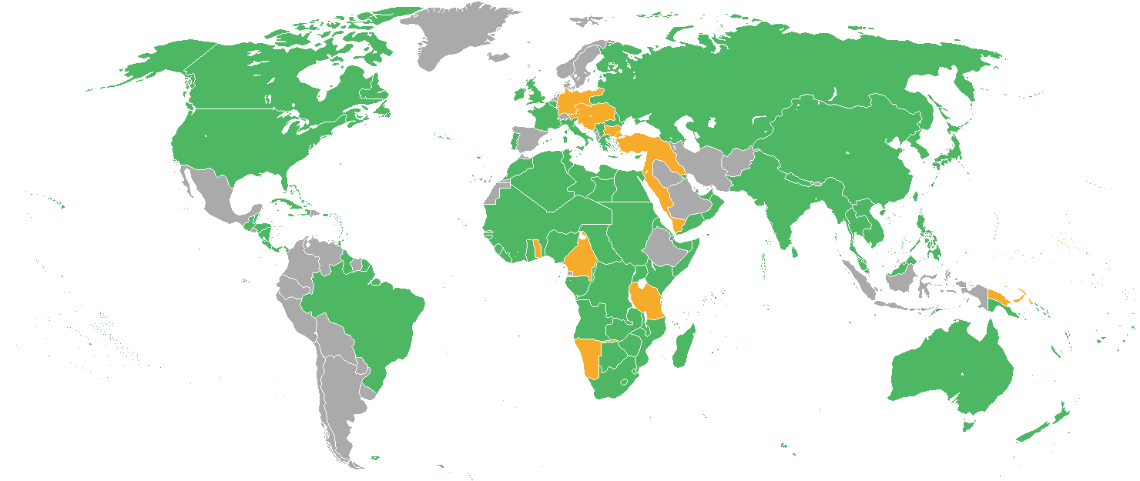
World map showing the nations of the world highlighted according to whether they fought with the Allied Powers or the Central Powers in World War I.
World War I was truly a world-wide war. Here, countries that were allied with the Triple Entente, known as the Allied Powers, are highlighted in green. Countries that were allied with the Central Powers are highlighted in orange. Map courtesy Wikimedia Commons.
The war pitted two groups of allies against each other: the Triple Entente, composed of Russia, France, and the United Kingdom, against the Central Powers, Germany and Austria-Hungary.
Though everyone believed the war would be quick and decisive, it instead bogged down in a prolonged war of attrition, with soldiers in the trenches fighting ferociously to move the battle lines by mere inches.^22squared

The United States enters World War I
US President Woodrow Wilson sought to maintain US neutrality but was ultimately unable to keep the United States out of the war, largely because of escalating German aggression. On May 7, 1915, the Germans sunk the British ocean liner RMS Lusitania, which had over a hundred Americans on board. Wilson warned that the United States would not permit unrestricted submarine warfare or any further violations of international law.
In January 1917, the Germans resumed submarine warfare. A few days after this announcement, the Wilson administration obtained a copy of the Zimmermann Telegram, which urged Mexico to join the war effort on the side of Germany and pledged that in the event of a German victory, the territories of Arizona, Texas, and New Mexico would be stripped from the United States and returned to Mexico. The publication of the Zimmermann Telegram and the escalation of German submarine attacks on US merchant vessels led the US Congress to declare war on Germany on April 6, 1917.
More than 1.3 million men and twenty thousand women enlisted in the armed forces.^33cubed Though some Americans opposed US entry into the war, many believed they had a civic duty to support the war effort. US government propaganda sought to mobilize the American citizenry through appeals to patriotism and civic duty, and by linking US democracy with support for the democracies of Western Europe.

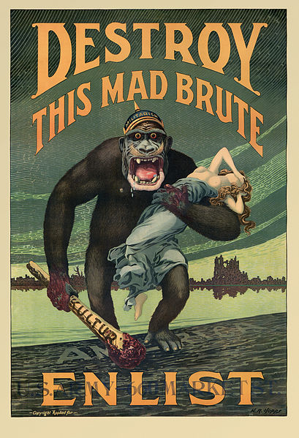
Propaganda poster depicting Germany as a mad gorilla intent on invading the United States.
Propaganda poster for the American war effort in World War I, 1917. The poster portrays Germany as a mad gorilla that would turn its sights on American shores if not defeated in Europe. Image courtesy Wikimedia Commons.
The Selective Service Act of 1917 authorized the conscription of military manpower for the war effort so that the United States did not have to rely solely on volunteers.^44start superscript, 4, end superscript Because many American citizens believed it was their patriotic duty to support the war effort, the draft was well-received and rates of draft-dodging were relatively low.

World War I on the home front
The First World War had an enormous impact on US politics, culture, and society. Advocates of female suffrage successfully linked the patriotic efforts of women in the war with voting rights. This strategy was highly effective, and in 1920, the US Congress ratified the Nineteenth Amendment, which guaranteed women the right to vote.^55start superscript, 5, end superscript
Others were not so lucky. Hyper-vigilance on the home front led to spontaneous outbreaks of violence against groups whose loyalty to the United States was considered suspect. German-Americans, labor activists, suffragists, immigrants, African Americans, and socialists were subjected to threats, harassment, imprisonment, and physical violence.
At the same time, civil liberties were sharply curtailed. The Espionage Act of 1917 and the Sedition Act of 1918 criminalized the expression of antiwar sentiment and criticism of the US government and armed forces. Voluntary associations were created to identify dissidents, and many of these worked together with the Federal Bureau of Investigation to patrol the home front and punish perceived “enemies.”^66start superscript, 6, end superscript

Aftermath: consequences of World War I
The experience of the First World War was traumatizing. The so-called “civilized” Western democracies had plunged into a ferocious and deadly conflict with uncertain origins and an unsatisfying outcome. As a result, many became disillusioned with the values and ideals of American political democracy and consumer culture. The generation that came of age during the First World War and the “Roaring 1920s” is known as the “Lost Generation.”
On the political front, a debate erupted between President Wilson and his supporters, who sought an expanded role for the United States in world affairs, and isolationists in Congress, who feared becoming embroiled in future European conflicts. Though Wilson was the foremost advocate of the League of Nations, an international peacekeeping organization, the United States never officially joined the League due to isolationist opposition.^77
https://www.khanacademy.org/humanities/us-history/rise-to-world-power/us-in-wwi/a/the-united-states-in-world-war-i

