Westward Expansion: Economic Development

https://www.khanacademy.org/humanities/ap-us-history/period-6/apush-westward-expansion-economic-development/a/westward-expansion-economic-development
In the late nineteenth century, the West developed into a modern agricultural machine--at the expense of farmers.

Overview
- Land, mining, and improved transportation by rail brought settlers to the American West during the Gilded Age.
- New agricultural machinery allowed farmers to increase crop yields with less labor, but falling prices and rising expenses left them in debt.
- Farmers began to organize in local and regional cooperatives like the Grange and the Farmers’ Alliance to promote their interests.

Who owns the West?
When Thomas Jefferson imagined the ideal environment for the republic to thrive, he pictured a country made up of small farms. Independent farmers would make an honest living tilling the soil, and in doing so, they would become virtuous citizens.
Before the Civil War, the Free-Soil movement and the Republican Party embraced this idea for the American West: a territory reserved for small white farmers, unchallenged by the wealthy plantation owners who could buy up vast tracts of land and employ slave labor. (The indigenous residents of the West did not figure into their vision, except as obstacles to remove).
During the Civil War, the Republican-controlled Congress worked to make the dream of a farmer’s paradise a reality by passing the Homestead Act, which granted up to 160 acres of western land to loyal citizens. The US government also helped westward expansion by granting land to railroad companies and extending telegraph wires across the country.^11start superscript, 1, end superscript
After the Civil War, the dream of independent farms remained, but the reality was more complex. Just as big business was coming to dominate the factories of eastern cities, so too were powerful corporate interests beginning to elbow out the independent farmers, miners, and cowboys who had built the image of the West as the land of opportunity for the rugged individual.

Developing the West
A variety of factors enticed American settlers and immigrants to head west in the late nineteenth century. Chief among these was the availability of cheap land for farming, logging, and ranching. Hundreds of thousands of people obtained land through the Homestead Act: through it, the US government transferred more than 270 million acres of public lands into private hands.^22squared
The discovery of precious metals and minerals also drew people to the West. Miners discovered gold, silver, and copper in several western states. The discovery of silver in the Comstock Lode in Nevada in 1858 prompted the largest rush of prospectors since the California gold rush a decade earlier. Hordes of miners looking to strike it rich created short-lived “boomtowns” that swiftly turned into abandoned “ghost towns” when the communities exhausted the easily-accessible minerals. By the 1880s, only large mining corporations had the money and machinery necessary to undertake the difficult work of extracting ore from deep in the earth.^33cubed
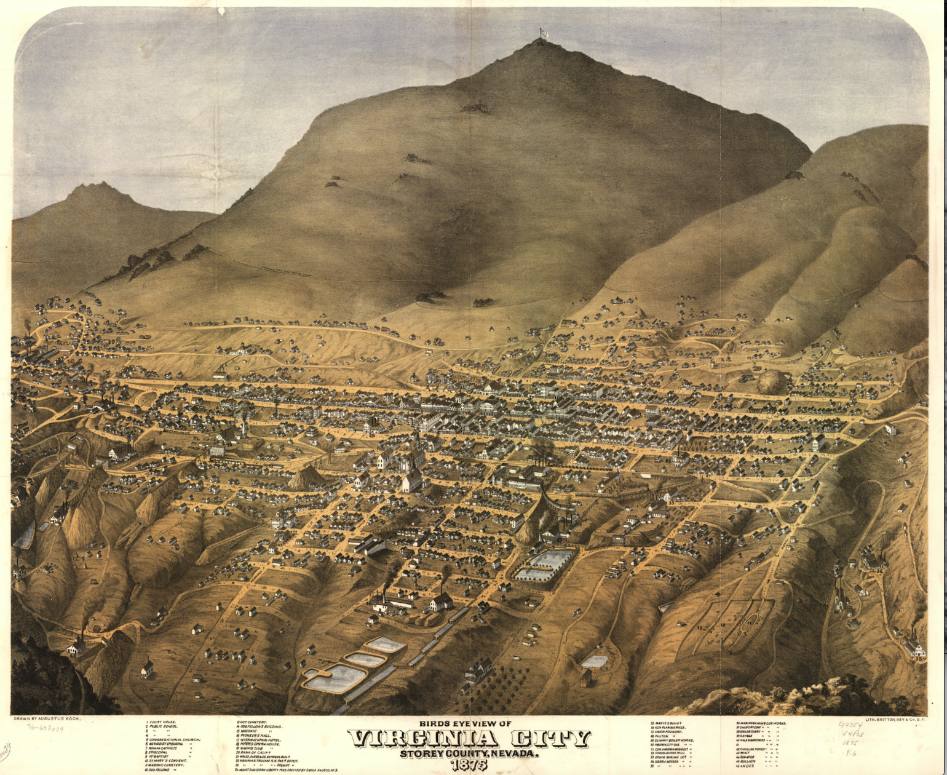
Artist's depiction of the town of Virginia City.
Artist’s depiction of Virginia City, a mining boomtown that sprang up in Nevada after the discovery of the Comstock Lode. Image credit: Wikimedia Commons
But the greatest contributor to the development of the West was the railroad. Eager to promote trade and transportation, federal, state, and local governments granted land to railroad companies. The companies used that land to triple the miles of railroad track in the United States between 1860 and 1880, all while turning a tidy profit selling excess land to settlers and speculators.^44start superscript, 4, end superscript
The railroads opened up the West not only to settlement but to the world market, making it possible to ship meat and crops to distant cities and even across oceans. To do so, the railroads even transformed time itself: in 1883 the railroad companies coordinated their schedules by dividing the United States into four time zones, which are still the standard today.^55start superscript, 5, end superscript

Farmers in an industrial age
The industrial innovation of the Gilded Age also revolutionized farming. New machinery increased the speed of planting and harvesting crops. Invented in the late nineteenth century, the twine-binder, “combine” (combined reaper-thresher), and gasoline tractor increased harvest yields and decreased the amount of labor needed to produce them.
But this new productivity came at a steep price. Thanks to the railroad, farmers were now at the mercy of a competitive worldwide market. Unlike earlier subsistence farmers, who had grown a variety of crops and produced everything necessary for their families, American farmers now focused their efforts on growing a single
cash crop
(usually corn or wheat in the West) and buying everything else they needed. When crop prices were high, the farmers did well. But if prices dropped, the farmers were in trouble.
And in the late nineteenth century, farmers were in trouble. To some extent, they were the victims of their own success: the more they produced, the less it was worth. But farmers also found themselves contending with unfavorable government policies and unchecked corporate monopolies. The US government enacted high protective tariffs for industry and a deflationary monetary policy, both of which placed farmers at a financial disadvantage. Railroad monopolies charged shipping rates so high that in some cases it was cheaper for farmers to burn their crops for fuel than to ship them to market. Farm machinery and fertilizer were also subject to steep markups. All of these factors combined to drive farmers into debt and bankruptcy.^66start superscript, 6, end superscript

The Grange and the Farmers’ Alliance
Frustration with their circumstances led farmers to band together in cooperative organizations. The Order of Patrons of Husbandry, commonly called the Grange, formed in 1867. The Grange called for increased railroad regulations and cooperative buying and selling of equipment and produce. At its height, the Grange had more than 700,000 members, mainly in the upper midwest states of Illinois, Iowa, Minnesota, and Wisconsin.^77start superscript, 7, end superscript
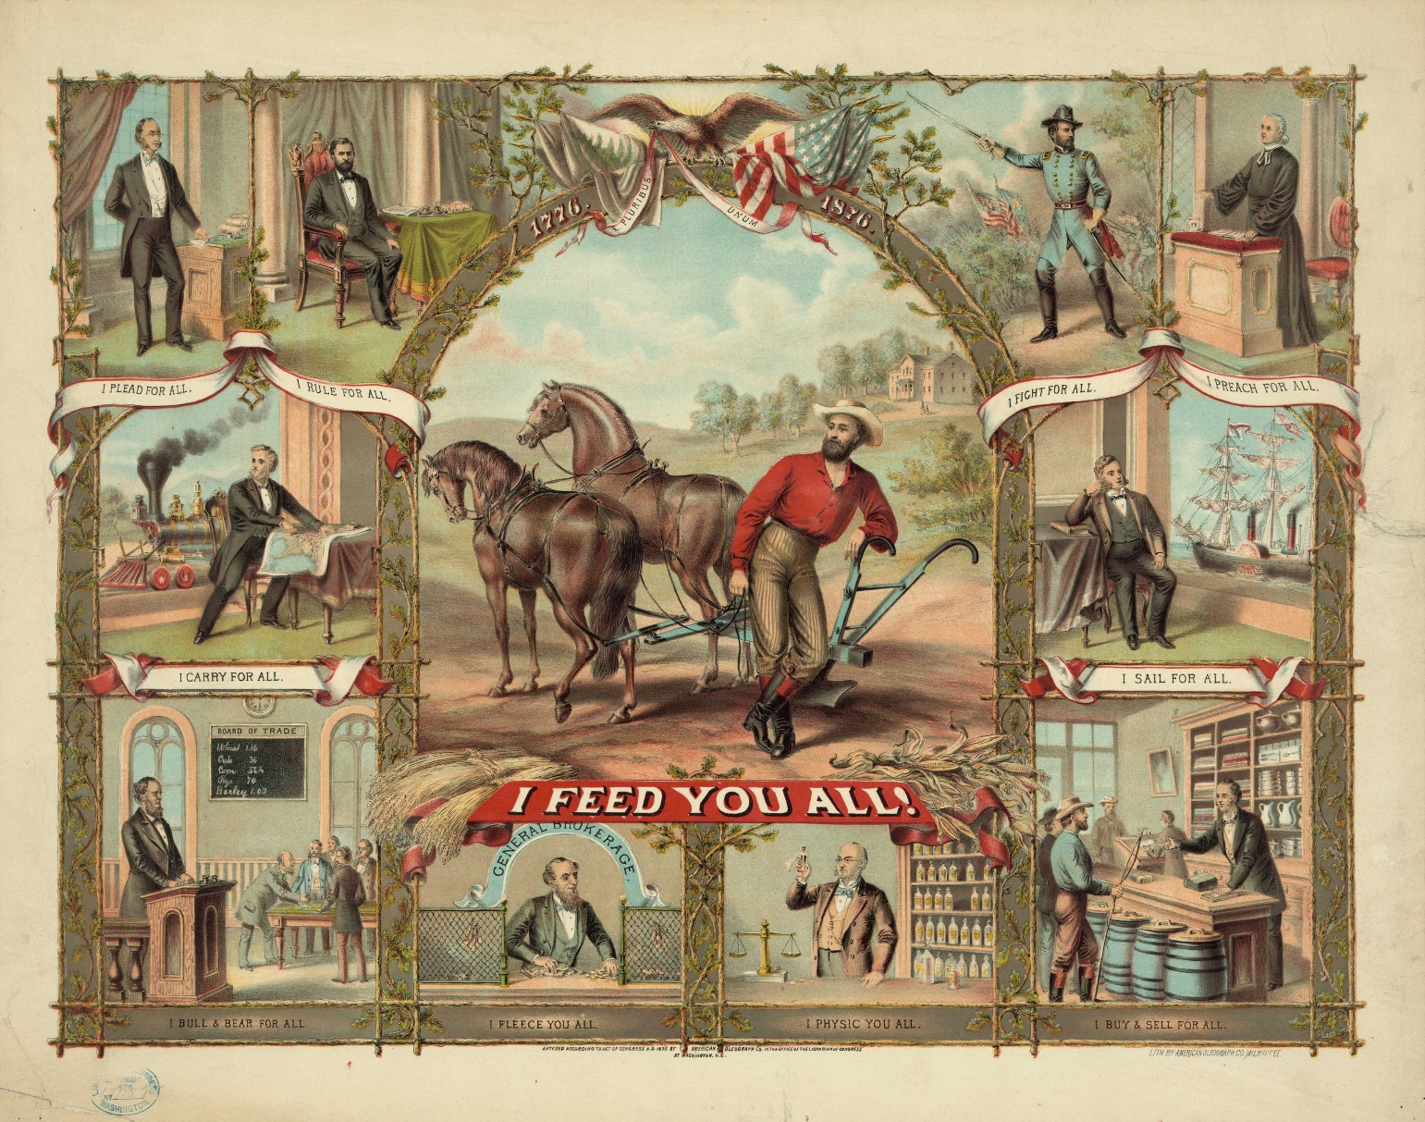
Print showing the farmer as the central figure feeding lawyers, presidents, railroad magnates, teachers, shopkeepers, sailors, presidents, and preachers.
“I Feed You All!” Poster for the Grange, 1875. Image credit: Library of Congress
In the late 1870s, an even larger organization, the Farmers’ Alliance, spread among southern and western farmers. The Farmers’ Alliance established “exchanges” that would issue loans to farmers and sell their crops, and proposed that the federal government loan money to farmers at low interest rates and create warehouses to store their crops. By 1890, the Farmers’ Alliance had more than three million members. Strictly segregated, the Alliance did not accept African American farmers into its ranks. They created a separate Colored Farmers’ Alliance with more than one million members.^88start superscript, 8, end superscript
Although neither the Grange nor the Farmers’ Alliance effected long-term economic change for farmers, these cooperative organizations would emerge on the national political stage as the Populist Party in the 1890s.

What do you think?
What were the major economic factors that drew settlers to the West in this time period?
What were the benefits and drawbacks of the expansion of the railroad?
Why did farmers face difficulties in the late nineteenth century? What do you think was the biggest issue they faced?

