The New South

https://www.khanacademy.org/humanities/ap-us-history/period-6/apush-the-new-south-lesson/a/the-new-south
Could the American South be remade as an industrial economy like the North?

Overview
- Proponents of the New South envisioned a post-Reconstruction southern economy modeled on the North’s embrace of the Industrial Revolution.
- Henry W. Grady, a newspaper editor in Atlanta, Georgia, coined the phrase the "New South” in 1874. He urged the South to abandon its longstanding agrarian economy for a modern economy grounded in factories, mines, and mills.
- Although textile mills and tobacco factories emerged in the South during this time, the plans for a New South largely failed. By 1900, per-capita income in the South was forty percent less than the national average, and rural poverty persisted across much of the South well into the twentieth century.

Rural agrarian poverty
After the Civil War, sharecropping and tenant farming took the place of slavery and the plantation system in the South.
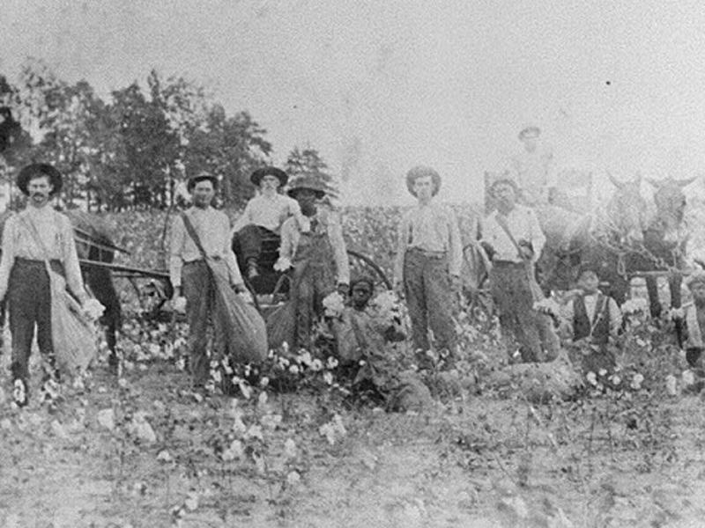
Sharecropping and tenant farming were systems in which white landlords (often former plantation slaveowners) entered into contracts with impoverished farm laborers to work their lands. Those who worked the fields shared a portion of the crop yield with the landlord as payment for renting the land. Under the sharecropping system, the landlord typically supplied the capital to buy the seed and equipment needed to sow, cultivate, and harvest a crop, while the sharecropper supplied the labor. In other tenancy farming arrangements the laborer, not the landowner, took responsibility for purchase of seed and equipment.

Photograph of black and white men and women picking cotton in a field.
Sharecroppers in Georgia, c. 1910. Both white and black farm laborers worked in the sharecropping system.
Image courtesy Georgia Archives.
Yet, because prices on cotton and other crops remained low, sharecroppers and tenant farmers often fell into a cycle of indebtedness called debt peonage: farmers found that the money they made selling their crops at the end of the growing season was not enough to pay back the loans they had taken out for seed, tools, farm equipment, and living expenses, leaving them owing more after a year of labor than they had when they started.
This system left both black and white tenant farmers living in dire poverty. In addition, since no one had any money to spend, the southern economy stagnated.

An economic vision for a new South
Enter Henry W. Grady, editor of the Atlanta Constitution, a newspaper in Georgia’s capital city. In a series of impassioned public speeches and articles, Grady envisioned a southern economy enriched with broadly expanded manufacturing facilities and commerce. Grady and like-minded southerners referred to this regional economic remake as the “New South.”
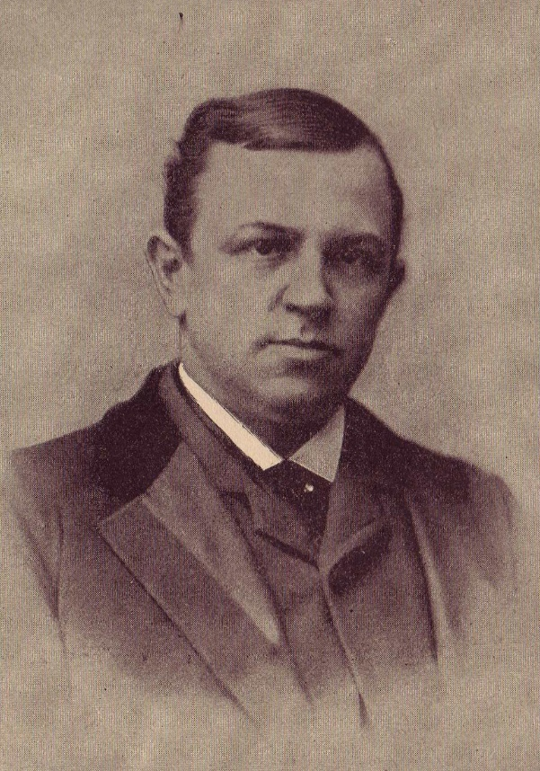
Portrait of Henry Grady.
Henry Grady. Image courtesy Wikimedia Commons.
Following the Civil War, the North experienced a period of rapid industrialization and technological advancement known as the Second Industrial Revolution. But the dynamic and expansive economic growth that came to the North in consequence of the Second Industrial Revolution largely bypassed the South. Proponents of the New South wanted the nation’s southern states to remake themselves along similar lines.^22squared

Successes and failures of the New South
There were some New South successes. Birmingham, Alabama prospered from iron and steel manufacturing, and mining and furniture production benefited other parts of the South. Likewise, James Duke made use of newly-invented cigarette rolling machines to feed the growing market for tobacco and founded the American Tobacco Company in North Carolina in 1890.
The most notable New South initiative was the introduction of textile mills in the South. Beginning in the early 1880s, northern capitalists invested in building textile mills in the southern Appalachian foothills of North Carolina, South Carolina, and Georgia, drawn to the region by the fact that they could pay southern mill workers at half the rate of workers in northern mills. Due to these low wages, the mills gave only a modest boost to the southern economies in which they were built.
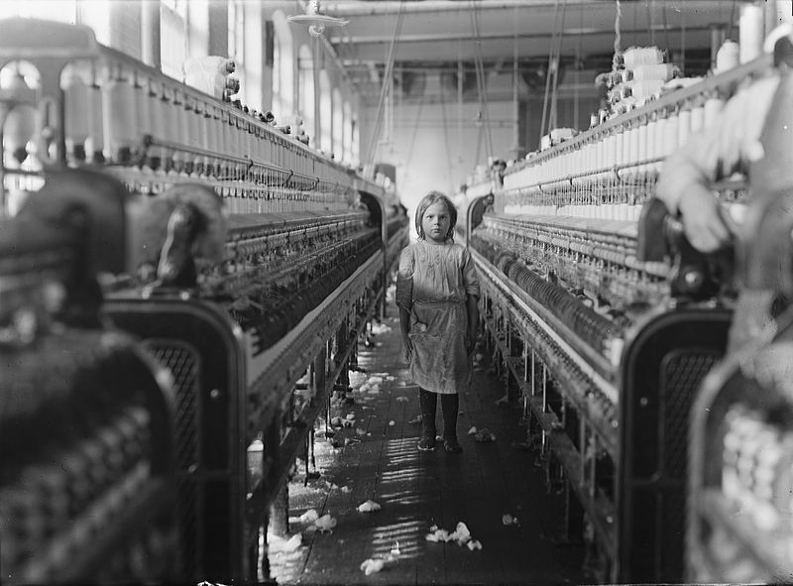
Photograph of a white girl, approximately age 6, standing among two rows of textile machines in a mill.
Child laborer in a South Carolina textile mill, 1908. Photograph by Lewis Hine. Image courtesy Library of Congress.
Although new industries did emerge in this era, the benefits of the New South did not accrue to African Americans or poor whites. Although Grady dreamed of a new South of increasing economic prosperity, his vision did not extend to civil rights for African Americans. "I declare,” said Grady in an 1888 address, “that . . . the white race must dominate forever in the South.” In the New South, landlords and factory owners prospered, but sharecropping and low-wage factory work kept many across the region from escaping dire poverty.

What do you think?
What kept the southern economy from prospering in the post-Civil War era?
What do you think your life would have been like if you had been a sharecropper or a textile mill worker in the late nineteenth and early twentieth century South?
Why do you think Henry W. Grady’s vision of the New South did not include equality for African Americans?

