The Homestead Act and the Exodusters

https://www.khanacademy.org/humanities/ap-us-history/period-6/apush-westward-expansion-social-and-cultural-development-lesson/a/the-homestead-act-and-the-exodusters
The Homestead Act of 1862 gave free land to Americans willing to improve it, regardless of race, sex, or nation of origin.

Overview
- The Homestead Act of 1862 parceled out millions of acres of land to settlers. All US citizens, including women, African Americans, freed slaves, and immigrants, were eligible to apply to the federal government for a “homestead,” or 160-acre plot of land.
- Homesteading was a contentious issue, because Northerners and Republicans wanted to open the land to settlement by individual farmers, while Southern Democrats sought to make the land available only to slaveholders.
- The exodusters were African American migrants who left the South after the Civil War to settle in the states of Colorado, Kansas, and Oklahoma.

Background to the Homestead Act
The Homestead Act of 1862 was not the first land-grant legislation in US history. In fact, the practice of governments awarding free land to settlers dates back to early colonial period, when the British encouraged settlement of the “New World” by granting settlers the claims to vast swathes of land. And ever since the Northwest Ordinance of 1787, which established the Northwest Territory (modern-day Illinois, Indiana, Michigan, Minnesota, Ohio, and Wisconsin) and prohibited the extension of slavery into that territory, land-grant legislation has been inextricably tied to the issue of slavery. A competition ensued over the admission of free states and slave states into the Union.^11start superscript, 1, end superscript
Homesteading was contentious because northerners and Republicans wanted to free up large plots of land to settlement by individual farmers, while Southern Democrats sought to make the lands of the west available only to slave-owners. Congress had passed a homestead act in 1860, but President James Buchanan, a Democrat, vetoed it. Only after the Southern states had seceded from the union in 1861 could the Homestead Act be passed. After Congress was emptied of Southern slaveholding legislators, President Abraham Lincoln, a Republican, signed the Homestead Act of 1862.

The Homestead Acts
A homestead was a plot of land, typically 160 acres in size, that was awarded to any US citizen who pledged to settle and farm the land for at least five years. The only requirements were that the applicant must be at least 21 years of age (or be the head of a household) and the applicant must never have “borne arms against the United States Government or given aid and comfort to its enemies.”^22squared After the Civil War, this meant that ex-Confederate soldiers were ineligible to apply for a homestead. With the passage of the Fourteenth Amendment, which guaranteed US citizenship to African Americans and ex-slaves, homesteading became a possibility for freedpeople. And after a Supreme Court decision in 1898, immigrants became eligible to apply to the federal government for a homestead as well, though by that time, the best lands had already been claimed.
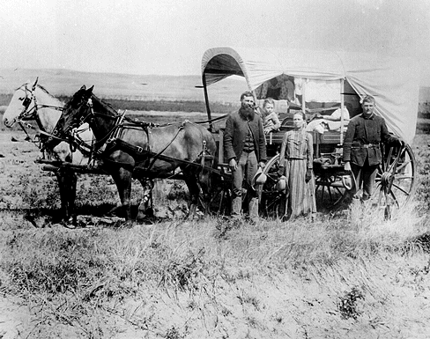
Photograph of a white family in a covered wagon standing on the prairie.
A family of homesteaders. Image courtesy National Archives.
From 1862 to 1934, the federal government granted over a million and a half homesteads to private citizens. This represented approximately ten percent of the entire landmass of the United States.^33cubed It was a massive transfer of land ownership from the federal government to individual citizens, and inaugurated a series of “land rushes,” during which homesteaders rushed in to settle the land on a first-come, first-serve basis. The Homestead Act facilitated the rapid settlement of territories in the West and Midwest United States.

The Exodusters
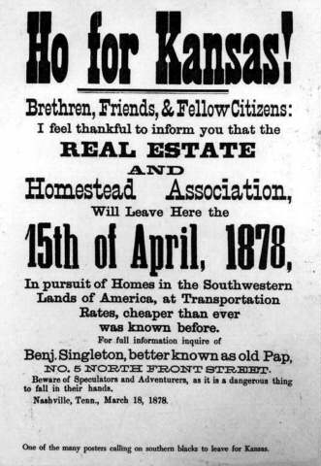
As Jim Crow segregation became entrenched in the South during Reconstruction, racial violence and the pervasive repression of African Americans created a hostile environment. After the Compromise of 1877 removed federal protections for African Americans in the South, it became clear that anyone who attempted to resist racial oppression would be subjected to vigilante justice at the hands of the Ku Klux Klan or other white supremacist organizations. Little wonder that many Southern blacks sought to escape.
The Exodus of 1879 was the first mass migration of African Americans from the South after the Civil War. These migrants, most of them former slaves, became known as exodusters, a name which took inspiration from the biblical Exodus, during which Moses led the Hebrews out of slavery in Egypt and into the Promised Land. The exodusters settled in the states of Colorado, Kansas, and Oklahoma. Kansas was seen as a particularly promising land of opportunity, because it had fought hard for its status as a free state. A handbill advertising homestead for African Americans. It reads: Ho for Kansas! Brethren, Friends & Fellow Citizens: I feel thankful to inform you that the REAL ESTATE and Homestead Association, Will Leave Here the 15th of April, 1878, In pursuit of Homes in the Southwestern Lands of America, at Transportation Rates, cheaper than ever was known before. free state. A handbill advertising homestead for African Americans. It reads: Ho for Kansas! Brethren, Friends & Fellow Citizens: I feel thankful to inform you that the REAL ESTATE and Homestead Association, Will Leave Here the 15th of April, 1878, In pursuit of Homes in the Southwestern Lands of America, at Transportation Rates, cheaper than ever was known before. For full information inquire of Benj. Singleton, better known as old Pap, NO. 5 FRONT STREET. Beware of Speculators and Adventurers, as it is a dangerous thing to fall in their hands. Nashville, Tenn., March 18, 1878.
A handbill advertising homesteading to African Americans. Image courtesy Library of Congress.
The reality of life for the exodusters in Kansas was difficult, however, and many of those who attempted to homestead the land remained poor. The most successful exodusters were those who migrated to urban areas like Topeka and found domestic or trade work. Despite Kansas’s reputation as a land of opportunity for blacks, many whites resented their presence, and the efforts of local governments to provide relief to the new arrivals frequently failed. As a result, the exodusters founded several black communities, such as the one at Nicodemus, Kansas.^44start superscript, 4, end superscript

What do you think?
Why was federal land grant legislation so contentious?
In your opinion, did the Homestead Act of 1862 contribute to the onset of the Civil War?
Why did the exodusters leave the South after the Civil War? Do you think life was better for them in the areas to which they migrated?

