The Gold Rush
https://www.khanacademy.org/humanities/ap-us-history/period-6/apush-america-in-transition-setting-the-stage-lesson/a/the-gold-rush
The 1848 discovery of gold in the territory of California prompted 300,000 hopeful prospectors to flood into the region, altering it forever.

Overview
- The 1848 discovery of gold in California set off a frenzied Gold Rush to the state the next year as hopeful prospectors, called “forty-niners,” poured into the state.
- This massive migration to California transformed the state’s landscape and population.
- The Gold Rush was characterized by violent clashes among settlers, miners, and Native Americans over access to the land and its natural resources.

The California Gold Rush
On January 8, 1848, James W. Marshall, overseeing the construction of a sawmill at Sutter’s Mill in the territory of California, literally struck gold. His discovery of trace flecks of the precious metal in the soil at the bottom of the American River sparked a massive migration of settlers and miners into California in search of gold. The Gold Rush, as it became known, transformed the landscape and population of California.

Arriving in covered wagons, clipper ships, and on horseback, some 300,000 migrants, known as “forty-niners” (named for the year they began to arrive in California, 1849), staked claims to spots of land around the river, where they used pans to extract gold from silt deposits.
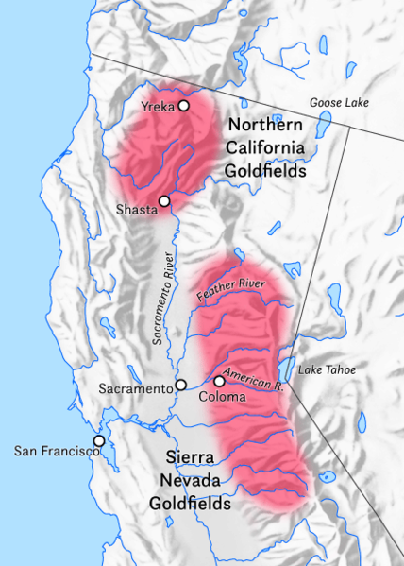
Prospectors came not just from the eastern and southern United States, but from Asia, Latin America, Europe, and Australia as well. Improvements in steamship and railroad technology facilitated this migration, which dramatically reshaped the demographics of California. In 1849, California established a state constitution and government, and formally entered the union in 1850.
Map of Northern California highlighting the regions to which gold prospectors flocked. The prospectors came to the Sierra Nevada mountains east and north of San Francisco.
Map of the areas in Northern California to which gold prospectors flocked. Map courtesy Wikimedia Commons.

Life as a forty-niner
Though migration to California was fueled by gold-tinted visions of easy wealth and luxury, life as a forty-niner could be brutal. While a small number of prospectors did become rich, the reality was that gold panning rarely turned up anything of real value, and the work itself was back-breaking.
The lack of housing, sanitation, and law enforcement in the mining camps and surrounding areas created a dangerous mix. Crime rates in the goldfields were extremely high. Vigilante justice was frequently the only response to criminal activity left unchecked by the absence of effective law enforcement. As prospectors dreaming of gold poured into the region, formerly unsettled lands became populated, and previously small settlements, such as the one at San Francisco, exploded.

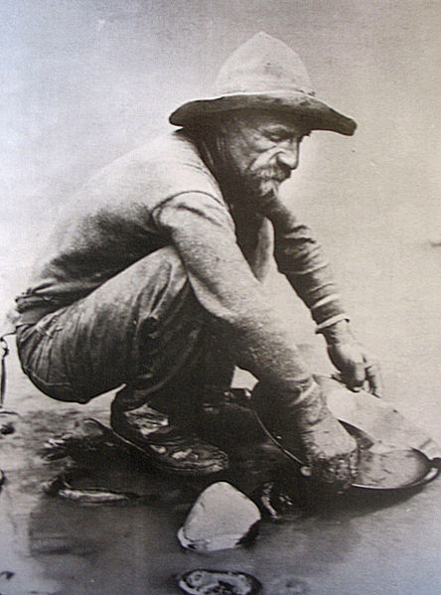
Photograph of a white male forty-niner panning for gold.
A forty-niner panning for gold in the American River, 1850. Image courtesy Wikimedia Commons.
As competition flared over access to the goldfields, xenophobia and racial prejudice ran rampant. Chinese and Latin American immigrants were routinely subjected to violent attacks at the hands of white settlers and miners who adhered to an extremely narrow view of what it meant to be truly “American.”
As the state government of California expanded to oversee the booming population, widespread nativist (anti-immigrant) sentiment led to the establishment of taxes and laws that explicitly targeted immigrants, particularly Chinese immigrants.
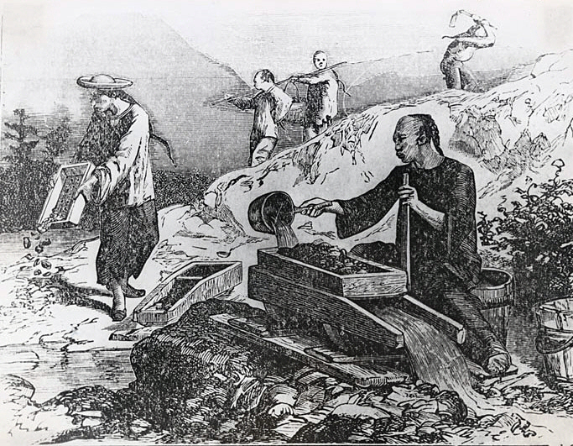
Illustration depicting Chinese men panning for gold.
Illustration depicting Chinese gold prospectors during the Gold Rush. Image courtesy Wikimedia Commons.

Violence across the land
As agriculture and ranching expanded to meet the needs of the hundreds of thousands of new settlers, white settlers' violence toward Native Americans intensified. Peter Hardeman Burnett, the first governor of California, openly declared his contempt for the native population and demanded its immediate removal or extinction. Under Burnett’s leadership, the state of California paid bounties to white settlers in exchange for Indian scalps. As a result, vigilante groups of miners, settlers, and loggers formed to track down and exterminate California’s native population, which by 1890 had been almost completely decimated.
Though the Gold Rush had a transformative effect on California’s landscape and population, it lasted for a surprisingly brief period, from 1848 to 1855. It did not take long for gold panning to turn up whatever gold remained in silt deposits, and as the extraction techniques required to mine for gold became increasingly complex, gold mining became big business. As the mining industry exploded, individual gold-diggers simply could not compete with the level of resources and technological sophistication of the major mining conglomerates.

What do you think?
How did the Gold Rush reshape the demographics of California?
If you had lived in this time period, would you have participated in the Gold Rush? Why or why not?
What were the long-term effects of the California Gold Rush?

