# ___# Name:_____________________________________ Date:________________________________

# 11th Grade APUSH Ms. Ruthie García-Vera PJMJCH Colegio Marista

**DBQ The Debate Over American Imperialism**

**Historical Context:**

The final decades of the nineteenth century saw a mad scramble as the powerful, and aspiring powerful, nations of the world attempted to gain control of areas in Asia, Africa, the Middle East and elsewhere in order to build and consolidate their empires. This outbreak of colonialism found its origins in the industrial nations securing raw materials for their factories and captive markets for their manufactured goods. Often the colonies would be sought for military reasons. The coal-fired navies of these nations required bases from which they could easily refuel. The strategic location of these bases around the globe meant that they could protect their far-flung empires more easily. Just the act of possessing colonies became a source of bragging rights for nations who were seeing a rise in nationalism at home. Obtaining and controlling vast colonial empires was a source of pride. The British claimed, with great pride, that “the sun never sets on Great Britain.” Ironically, this period was soon to be followed by a rise in nationalism among these same colonial peoples.

During most of the 1800s, the United States ignored much of this activity and it was fought out almost entirely by European nations. We were busy conquering our own continent and spreading across the Great Plains to California and the Pacific Ocean. Colonial expansion held little interest until our own sense of nationalism began to be awakened in the late 1890s.

Ironically, our interest in colonial empire grew out of a desire to champion anti-colonialism and an interest in helping Cuba free itself from Spanish colonial rule. It ended with the United States in the possession of a colonial empire herself. The Spanish-American War, over quickly with few casualties, gained Guam, Puerto Rico and the Philippines. But from the war’s end in August 1898 until the Senate ratified the Treaty of Paris in February 1899 annexing these lands, a debate raged over whether or not a nation born in revolt against colonialism should itself become a ruler of colonies. This debate did not end with the ratification of the treaty but became even more impassioned when the Filipinos took up arms against American colonial occupation troops beginning two years of bloody struggle. As is often the case, this domestic quarrel over imperialism became a major political issue influencing the presidential election of 1900.

**Task:**

Consider why people objected to or supported America’s imperialism. Some felt it was immoral to rule over other peoples while others felt it was immoral to shirk our duty of assisting the less privileged of the world.

**Prompt:**

The period 1875-1920 has been described by some historians as a period of “selfless altruism” during which the United States defended weaker nations against aggrandizement by rapacious European powers and spread the “blessings of democracy and civilization.” Others have described the “New Manifest Destiny” as a time of “ruthless American expansion” at the expense of weaker nations and in violation of our own most sacred principles of consent of the governed and popular sovereignty.

**Was imperialism a proper and legitimate policy for the United States to follow at the end of the 19th Century and beginning of the 20th Century?**

**Directions:**

**Part A**

**Short Answer:**

The following documents relate to why people objected to and supported America’s policy of imperialism.

Examine each document carefully and then answer the question(s) which follow it. **Short sentences or**

**phrases may be used to answer the question, but DO NOT use one-word answers.**

**Part B**

**D**

**Document 1**

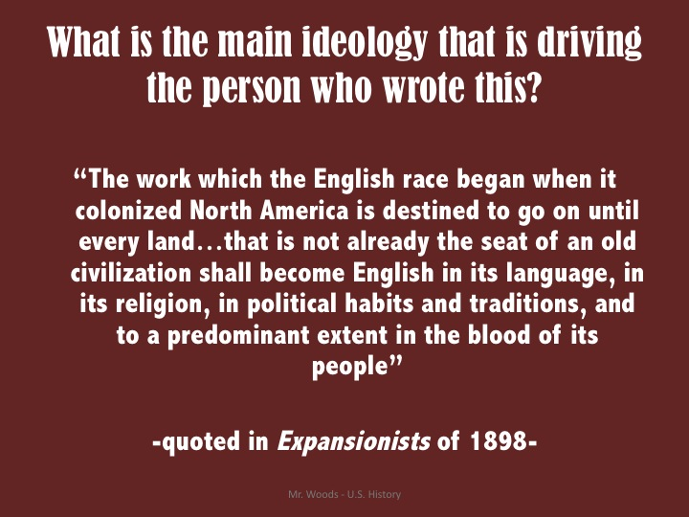

1. What was the main ideology driving the person who wrote this?

**Document 2**

More than a decade before the Spanish-American War, Rev. Josiah Strong, a prominent Protestant clergyman, wrote *Our Country*, a book that became both popular and influential. This passage is taken from Strong’s book and advocates imperialism as a policy of the United States.

*It seems to me that God, with infinite wisdom and skill, is training the Anglo-Saxon race [meaning people of American, English and German descent] for an hour sure to come in the world’s future...this race of unequaled energy, with all the majesty of numbers and the might of wealth behind it - the representatives ...of the largest liberty, the purest Christianity, the highest civilization...will spread itself over the earth...this powerful race will move down upon Mexico, down upon Central and South America, out upon the islands of the sea, over upon Africa and beyond. Can anyone doubt that the result...will be “survival of the fittest?”*

1. What do the Anglo-Saxons possess that makes them qualified as “the fittest?”
2. What action or events is he referring to when he mentions moving down on Mexico, Central and South America?
3. What does Strong mean when he mentions “survival of the fittest?” Explain.

**Document 3**

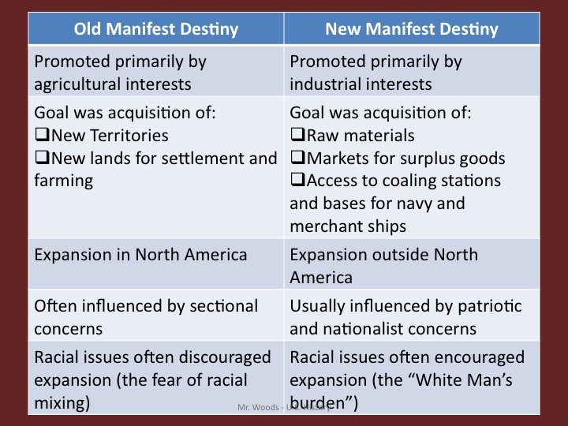

1. How was foreign policy influenced bt the New Manifest Destiny?

D**ocument 4**

Another American proponent of imperialism was a top U.S. Navy officer, Alfred T. Mahan. Mahan’s views were well known and popular with many. This excerpt comes from a book he wrote shortly before the Spanish-American War, entitled *The Interest of American Sea Power* (1897).

*American’s must begin to look outward. The growing production of the country demands it. An increasing volume of public sentiment demands it. The position of the United States, between two Old Worlds and two great oceans, makes the same claim.*

1. What three reasons does Mahan give for imperialism?
2. To what is Mahan referring when he cites “the growing production?”
3. Realizing that Mahan is a naval officer, why is he concerned about our position between two great oceans and two Old Worlds?

**Document 5**

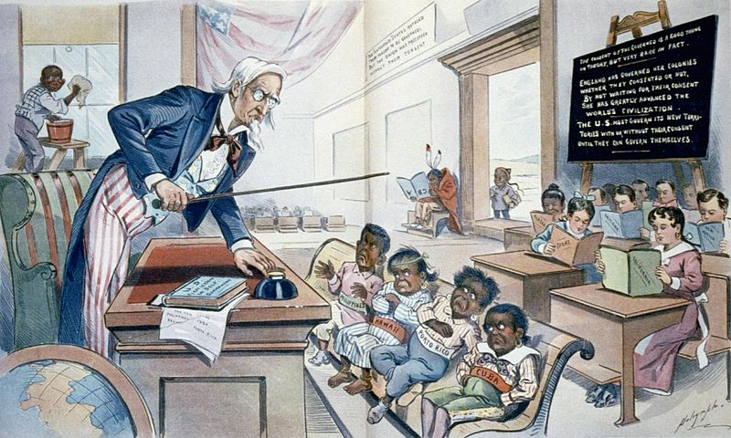

1. What issues in document 3 can be interpreted in the following cartoon? Why?

**Document 6**

The initial decision to annex the Philippines was made by President McKinley. In the following excerpt he explains why he recommended annexation to the U.S. Senate. He was speaking to a group of religious leaders.

*I walked the floor of the White House night after night until midnight; and I am not ashamed to tell you, gentlemen, that I went down on my knees and prayed to Almighty God for light and guidance...And one night late it came to me this way...*

1. *That we could not give them back to Spain-that would be cowardly and dishonorable;*
2. *that we could not turn them over to France or Germany - our commercial rivals in the Orient - that would be bad for business and discreditable;*
3. *that we could not leave them to themselves - they were unfit for self-government - and they would soon have anarchy and misrule there worse than Spain’s was; and*
4. *that there was nothing left for us to do but take them all, and to educate the Filipino, and uplift and civilize and Christianize them, and by God’s grace to do the very best we could for them, as our fellow men...*
5. To whom is McKinley addressing his remarks? What do the Anglo-Saxons possess that makes them qualified as “the fittest?” What action or events is he referring to when he mentions moving down on Mexico, Central and South America?
6. What does Strong mean when he mentions “survival of the fittest?” What does Strong state that would agree with these sentiments?” Explain.
7. What is ironic about McKinley’s desire to Christianize this former Spanish colony?

**Document 7**

U.S. Senator George F. Hoar represented Massachusetts in Congress from 1869 to his death in 1904. He was a major opponent of imperialism. The following is from a speech by Senator Hoar in January 1899 in opposition to the treaty annexing the Philippines.

...the question with which we now have to deal is whether Congress may conquer and may govern, without their consent and against their will, a foreign nation, a separate, distinct, and numerous people, a territory not hereafter to be populated with Americans...

...under the Declaration of Independence you cannot govern a foreign territory, a foreign people, and other people than your own...you cannot subjugate them and govern them against their will, because you think it is for their good, when they do not; because you think you are going to give them the blessings of liberty. You have no right at the cannon’s mouth to impose on an unwilling people your Declaration of Independence and your Constitution and you notions of freedom and notions of what is good.

1. To what two historic American documents does Hoar refer?
2. What does the Declaration of Independence say that supports Hoar?

**Document 8**

Henry Cabot Lodge, a Republican senator from Massachusetts, supported imperialism. This is a speech made by Lodge in 1900 in support of the policy of imperialism.

...we are in the Philippines as righteously [honorably] as we are there rightly and legally.

...The taking of the Philippines does not violate the principles of the Declaration of Independence, but will spread them among a people who have never known liberty, and who in a few years will be as unwilling to leave the shelter of the American flag as those of any other territory we ever brought beneath its folds.

1. To whom, specifically, do you think Lodge is addressing his remarks? Why do you think this?
2. Who do you think he means when he compares the Filipinos to others “who in a few years will be...unwilling to leave the shelter of the American flag?”

**Document 9**

The prospect of the United States becoming an imperialistic nation galvanized a strong opposition, and many opponents rallied around the newly created Anti-Imperialist League. The following are some excerpts from the Anti-Imperialist League’s platform which was adopted during the 1900 presidential campaign.

We hold that the policy known as imperialism is hostile to liberty and tends toward militarism, an evil from which it has been our glory to be free. We regret that it has become necessary, in the land of Washington and Lincoln to reaffirm that all men, of whatever race or color, are entitled to life, liberty and the pursuit of happiness. We maintain that governments derive their just powers from the consent of the governed. We insist that the subjugation of any people is “criminal aggression.”

...We hold, with Abraham Lincoln, that “no man is good enough to govern another man without that other’s consent.”

1. What do the Anti-Imperialists fear if we pursue the policy of imperialism?
2. What are they referencing when they say that all men “are entitled to life, liberty and the pursuit of happiness?”
3. From where does the phrase that “governments derive their just powers from the consent of the governed” come?

**Part B**

**Essay:**

Complete the **TASK** in a well-organized essay. The period 1875-1920 has been described by some historians as a period of “selfless altruism” during which the United States defended weaker nations against aggrandizement by rapacious European powers and spread the “blessings of democracy and civilization.” Others have described the “New Manifest Destiny” as a time of “ruthless American expansion” at the expense of weaker nations and in violation of our own most sacred principles of consent of the governed and popular sovereignty.

Consider why people objected to or supported America’s imperialism. Some felt it was immoral to rule over other peoples while others felt it was immoral to shirk our duty of assisting the less privileged of the world. The question we need to answer is:

**Was imperialism a proper and legitimate policy for the United States to follow at the end of the 19th Century and beginning of the 20th Century?**

**TIPS**

In writing your essay be certain that you **clearly state your thesis** whether this **was or was not a legitimate policy** for the United States. **Remember how people felt at this time** period and try to **think as they did** not as you might feel today at the beginning of the 21st Century. Each paragraph and each piece of evidence should **support your thesis**. Try to use or **refer to specific portions** of the documents that support your statement. In your essay refer to A MAJORITY of the documents you analyzed in Part A.

In an essay it is good to **acknowledge the opposition views** and state **what arguments** might be put forward to **contradict them**. Again, use quotes or **refer to the documents** that would support your opinion on this.

Start by using your **essay structure** document. Identify the documents you are using in your content. Once you have all your ideas clearly defined and organized, your final draft will be almost completed.

Remember to use at least **3 or more outside information** documents to justify your point of view and enrich your content. Do not forget to include your references.

These are some extra documents you may use:

## Document A

“The title to territory of indefinite but confessedly very large extent is in dispute between Great Britain and the Republic of Venezuela. . . . Venezuela can hope to establish her claim only through peaceful methods. . . . The Government of the United States has made it clear to Great Britain that the controversy is one in which both its honor and its interests are involved. . . . The people of the United States have a vital interests in the cause of popular self-government. . . . To-day the United States is practically sovereign on this continent, and its fiat is law upon the subjects to which it confines its interposition. . . . Its infinite resources combined with its isolated position render it master of the situation and practically invulnerable as against any or all other powers. . . . All the advantages of this superiority are at once imperiled if the principle be admitted that European powers may convert American States into colonies or provinces of their own. . . . Great Britain can not be deemed a South American state within the purview of the Monroe Doctrine. . . . It being clear, therefore, that the United States may legitimately insist upon the merits of the boundary question being determined, it is equally clear that there is but one feasible mode of determining them, viz., peaceful arbitration.” Richard Olney, Secretary of State, 1895.

# Document B

“The Republic of Hawaii hereby cedes absolutely and without reserve to the United States of America all rights of sovereignty of whatsoever kind in and over the Hawaiian Islands and their dependencies; and it is agreed that all territory of and appertaining to the Republic of Hawaii is hereby annexed to the United States of America under the name of the Territory of Hawaii. . . . The existing laws of the United States relative to public lands shall not apply to such lands in the Hawaiian Islands, but the Congress of the United States shall enact special laws for their management and disposition. . . . There shall be no further immigration of Chinese into the Hawaiian Islands, except upon such conditions as are now or may hereafter be allowed by the laws of the United States, and no Chinese by reason of anything herein contained shall be allowed to enter the United States from the Hawaiian Islands.” Treaty of Hawaiian Annexation, 1898.

# Document C

“The principles which this Government is particularly desirous of seeing formally declared by His Imperial Majesty and by all the great Powers interested in China, are:

First. The recognition that no Power will in any way interfere with any treaty port or any vested interest within any leased territory or within any so-called "sphere of interest" it may have in China.

Second. That the Chinese treaty tariff of the time being shall apply to all merchandise landed or shipped to all such ports as are within said "sphere of interest" (unless they be "free ports"), no matter to what nationality it may belong, and that duties so leviable shall be collected by the Chinese Government.

Third. That it will levy no higher harbor dues on vessels of another nationality frequenting any port in such "sphere" than shall be levied on vessels of its own nationality over equal distances.

The declaration of such principles by His Imperial Majesty would not only be of great benefit to foreign commerce in China. . . .” John Hay, Open Door In China , Pg.168.

# Document D

“On March 31 Captain-General Blanco issued a decree putting an end to reconcentration in the provinces of Pinar del Rio, Havana, Matanzas, and Santa Clara, and on April 9 the Spanish Cabinet decided to grant an armistice to the insurgents, while both the Pope and the great Powers of Europe were using their influence to avert a Spanish-American war. Nevertheless, the replies at this time of the Madrid government to President McKinley's demands concerning the pacification of Cuba, notwithstanding the Spanish offer to arbitrate the *Maine* trouble, led the authorities at Washington to believe that pacification could not be attained without the armed intervention of the United States. The President's message to Congress . . . . stated the entire issue, rightly considering the *Maine* disaster a subordinate matter, stated that the only hope of relief and repose from a condition which can no longer be endured is the enforced pacification of Cuba. In the name of humanity, in the name of civilization, in behalf of endangered American interests, which give us the right and the duty to speak and act, the war in Cuba must stop.” “Outbreak Of The War With Spain”, America, Vol.10, Pg.120.

# Document E

**Caribbean Interventions**

# Document F

“For more than a year the exact whereabouts of the elusive chieftain of the insurgent Filipinos had been a mystery. Rumor located Aguinaldo in all sorts of impossible places. Running up the bank toward the house, we were met by Segovia, who came running out, his face aglow with exultation, and his clothing spattered with the blood of the men he had wounded. He called out in Spanish, "It is all right. We have him." We hastened into the house, and I introduced myself to Aguinaldo, telling him that we were officers of the American army, that the men with us were our troops, and not his, and that he was a prisoner of war. He was given assurance that he need fear no bad treatment. He said in a dazed sort of way, "Is this not some joke?" I assured him that it was not, though, as a matter of fact, it was a pretty bad one, on him. With Aguinaldo in our hands, the Filipinos soon lost heart and the insurrection collapsed.” Senator George Frisbie Hoar, Subjugation of the Philippines Inquitous, The World's Famous Orations, Vol.3, Pg.220.

### Document G

“It is not true that the United States feels any land hunger or entertains any projects as regards the other nations of the Western Hemisphere, save such as are for their welfare. All that this country desires is to see the neighboring countries stable, orderly, and prosperous. . . . If a nation shows that it knows how to act with reasonable efficiency and decency in social and political matters, if it keeps order and pays its obligations, it need fear no interference from the United States. Chronic wrongdoing, or an impotence which results in a general loosening of the ties of civilized society, may in America, as elsewhere, ultimately require intervention by some civilized nation, and in the Western Hemisphere the adherence of the United States to the Monroe Doctrine may force the United States, however reluctantly, in flagrant cases of such wrongdoing or impotence, to the exercise of an international police power. . . . Our interests and those of our southern neighbors are in reality identical. We would interfere with them only in the last resort. . . .” [Theodore Roosevelt] A Compilation of the Messages and Papers of the Presidents (New York: Bureau of National Literature, 1906) vol. 16 (December 6, 1904), pp. 7053-7054.

# Document H

“The Republic of Panama grants to the United States in perpetuity, the use, occupation and control of a zone of land and land under water for the construction, maintenance, operation, sanitation and protection of said Canal of the width of ten miles extending to the distance of five miles on each side of the center line of the route of the Canal to be constructed; the said zone beginning in the Caribbean Sea three marine miles from mean low water mark and extending to and across the Isthmus of Panama into the Pacific Ocean to a distance of three marine miles from mean low water mark with the proviso that the cities of Panama and Colon and the harbors adjacent to said cities, which are included within the boundaries of the zone above described, shall not be included within this grant. . . . The Republic of Panama further grants in like manner to the United States in perpetuity, all islands within the limits of the zone above described and in addition thereto, the group of small islands, in the Bay of Panama, named Perico, Naos, Culebra and Flamenco. . . .The Republic of Panama grants to the United States all the rights, power and authority within the zone mentioned and described in Article II of this agreement, and within the limits of all auxiliary lands and waters mentioned and described in said Article II which the United States would possess and exercise, if it were the sovereign of the territory within which said lands and waters are located to the entire exclusion of the exercise by the Republic of Panama of any such sovereign rights, power or authority.” Theodore Roosevelt, Convention Between U. S. And Panama, Pg.480.

# Document I

“In view of the constant reiteration of the assertion that there was some corrupt action by or on behalf of the United States Government in connection with the acquisition of the title of the French Company to the Panama Canal and of the repetition of the story that a syndicate of American citizens owned either one or both of the Panama Companies, I deem it unwise to submit to the Congress all the information I have on the subject. These stories were first brought to my attention as published in a paper in Indianapolis, called the "News," edited by Mr. Delavan Smith. The stories were scurrilous and libelous in character and false in every essential particular. Mr. Smith shelters himself behind the excuse that he merely accepted the statements which had appeared in a paper published in New York, the "World," owned by Mr. Joseph Pulitzer.” Theodore Roosevelt, Purchase Of The Panama Canal, Pg.240.

# Document J

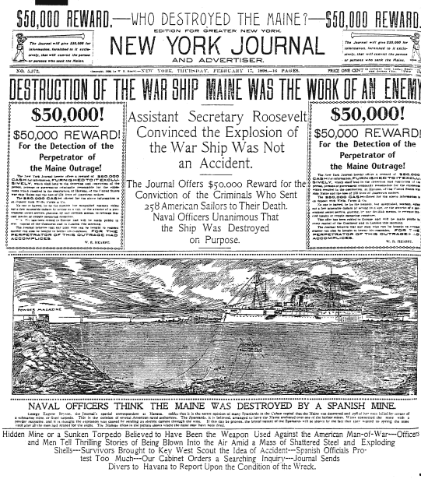

# Document K

“And now of a sudden, without cool deliberation, without prudent preparation, the nation is hurried into war, and America, she who more than any other land was pledged to peace and good will on earth, unsheathes her sword, compels a weak and unwilling nation to a fight, rejecting without due consideration her [Spain's] earnest and repeated offers to meet every legitimate demand of the United States. It is a bitter disappointment to the lover of his country; it is a turning back from the path of civilization to that of barbarism. There never was a good war," said Franklin. There have indeed been many wars in which a good man must take part. . . . But if a war be undertaken for the most righteous end, before the resources of peace have been tried and proved vain to secure it, that war has no defense. It is a national crime. The plea that the better government of Cuba, and the relief of the reconcentrados, could only be secured by war is the plea either of ignorance or of hypocrisy. But the war is declared; and on all hands we hear the cry that he is no patriot who fails to shout for it, and to urge the youth of the country to enlist, and to rejoice that they are called to the service of their native land. The sober counsels that were appropriate before the war was entered upon must give way to blind enthusiasm, and the voice of condemnation must be silenced by the thunders of the guns and the hurrahs of the crowd. Stop! A declaration of war does not change the moral law. "The Ten Commandments will not budge" at a joint resolve of Congress. . . . No! the voice of protest, of warning, of appeal is never more needed than when the press and too often the pulpit, is bidding all men fall in and keep step and obey in silence the tyrannous word of command. Then, more than ever, it is the duty of the good citizen not to be silent, and spite of obliquity, misrepresentation, and abuse, to insist on being heard, and with sober counsel to maintain the everlasting validity of the principles of the moral law.” Public Opinion 24 (June 23, 1898): 775-776.

### Document L

“Even if the condemnation of barbarous warfare in the Philippines by the imperialist press is somewhat belated, we welcome it, as we welcome everything that compels Americans to give attention to a subject to which too many of them have become increasingly indifferent. Silence, we know, is consistent with shame, and may be one of the signs of its existence; and the fact that only a few of the more unblushing or foolish newspapers have defended Gen. Smith's policy of extermination shows what the general sentiment is. To allege the provocation which our soldiers had is to set up a defense which President Roosevelt brushed aside in advance. To fall back on the miserable sophistry that "war is hell" is only another way of making out those who engage in that kind of war to be fiends. It is, besides, to offer an excuse for ourselves which we did not tolerate for an instant in the case of Spanish atrocities. That is our present moral humiliation in the eyes of the world.We made war on Spain four years ago for doing the very things of which we are now guilty ourselves. As the Chicago News pointedly observes, we are giving Spain as good reason to interfere with us on the ground of humanity as we had to interfere with her. Doubtless she would interfere if she were strong enough and thought she could acquire some islands in the virtuous act.” Nation (New York) 74 (May 8, 1902): 357.

### Document M

“When next I realized that the Philippines had dropped into our laps, I confess I did not know what to do with them. I sought counsel from all sides--Democrats as well as Republicans--but got little help. I thought first we would take only Manila; then Luzon; then other islands, perhaps, also. I walked the floor of the White House night after night until midnight; and I am not ashamed to tell you, gentlemen, that I went down on my knees and prayed Almighty God for light and guidance more than one night. And one night late it came to me this way--I don't know how it was, but it came:

(1) That we could not give them back to Spain--that would be cowardly and dishonorable;

(2) That we could not turn them over to France or Germany, our commercial rivals in the Orient--that would be bad business and discreditable.

(3) That we could not leave them to themselves--they were unfit for self-government, and they would soon have anarchy and misrule worse than Spain's was; and

(4) That there was nothing left for us to do but to take them all, and to educate the Filipinos, and uplift and civilize and Christianize them and by God's grace do the very best we could by them, as our fellow men, for whom Christ also died.

And then I went to bed and went to sleep, and slept soundly, and the next morning I sent for the chief engineer of the War Department (our map-maker), and I told him to put the Philippines on the map of the United States (pointing to a large map on the wall of his office), and there they are and there they will stay while I am President!” This document is a report of an interview with McKinley at the White House, November 21, 1899, written by one of the interviewers and confirmed by others present. Published in Christian Advocate, January 22, 1903.