Intentona de Yauco
By: Tony Santiago
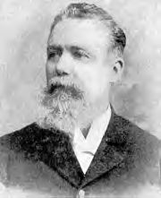
In 1896, a group of "Yaucanos" (as the natives of Yauco are known) who believed in full independence of Puerto Rico joined forces and met in Barrio Barinas of Yauco where they made plans to overthrow the government. The group was led by Antonio Mattei Lluberas, a wealthy coffee plantation owner, and Mateo Mercado. On December of that year, the local Civil Guard discovered their plans and proceeded to arrest all those involved who, besides Mercado and Mattei Lluberas, included Dario and Carlos Franchesi and Emiliano Lavergue, however they were soon released and returned to their respective homes. In 1897, Mattei Lluberas visited the Puerto Rican Revolutionary Committee in New York City. There he met with Ramon Emiterio Betances, Juan de Mata Terreforte and Aurelio Antonio Mattei Lluberas Méndez Martinez and together they proceeded to plan a major coup.
The uprising was to be directed by Betances, organized by Mendez Mercado and the armed forces were to be commanded by General Rius Rivera. At the time Ríus Rivera, who joined José Martí's struggle for Cuban independence as a member of the Cuban Liberation Army, was the Commander-in-Chief of the Cuban Liberation Army of the West. In accordance to the plan, Mattei Lluberas purchased 30,000 machetes which were to be distributed amongst the rebels. Mattei Lluberas returned to Puerto Rico with a Puerto Rican flag and began to proceed with the plans of the revolt with his group. The Budet Rivera brothers established an insurgent training camp in the farm of Gullermo Velazco. Fellow rebels, Gerardo Forest Velez and Agustin F. Morales (himself a general in the Army of the Dominican Republic), were in charge of propaganda and traveled throughout the island seeking public support for their cause. Cuban revolutionist Tomas Estrada Palma, offered a contribution of 500 rifles with half a million rounds of ammunition and his comrade offered a steamship with an invading force of 200 men under the command of General Agustin F. Morales.
The revolution was set for the beginning of the month of December 1897. The political situation at the time in Puerto Rico was different then the one in 1868, when "El Grito de Lares" occurred. Luis Muñoz Rivera and his Autonomist party had signed a pact with Praxedes Mateo Sagasta, the leader of the Spanish Liberal Party, which stated that if he (Sagasta) and the liberals assumed power in Spain, he would grant Puerto Rico autonomy. Thus, the political leaders of Puerto Rico believed that any attempt by the separatist movement to seek full independence for the island would be a threat to what they were trying to accomplish and instead of being granted more autonomy, the island would be dealt with harshly by the Spanish authorities. Therefore, when the Mayor of Yauco Francisco Lluch Barreras heard the rumors of the planned uprising, he immediately notified General Sabas Marín González the governor of the island.
Fidel Velez, a native of Sabana Grande and one of the separatist leaders, found out that the Spanish authorities knew about their plans and immediately held a meeting with Mattei Lluberas and the other leaders. Fearing that they all would soon be arrested, he demanded that the insurrection start immediately and not in December. In the discussion that followed, the other leaders did not agree with him, fearing that such a haste action would lead to the same disastrous results of El Grito de Lares. On March 24, 1897, Fidel Velez and his men met at Susua Arriba, just outside of Yauco. They unfurled the Puerto Rican flag for the first time in Puerto Rican soil and marched towards the town. They planned to attack the barracks of the Spanish Civil Guard with the aim of gaining control of the arms and ammunition, that were stored there. The plan did not succeed because when they arrived they were ambushed by the Spanish forces, who had set up positions and were waiting for them. A firefight ensued upon the arrival of the group and the rebels quickly retreated.
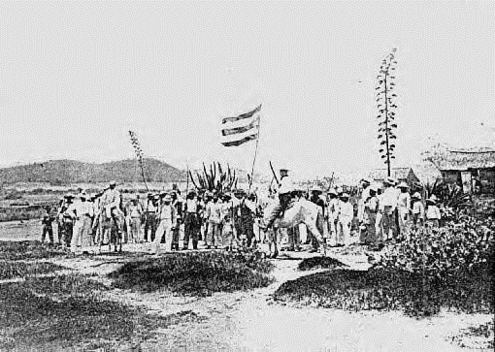
Flag flown by Fidel Vélez and his men during the "Intentona de Yauco" revolt.

On March 26, another group headed by Jose Nicolas Quiñones Torres and Ramon Torres attempted to fight the Spaniards in a barrio called "Quebradas" of Yauco, however said revolt also failed. Over 150 rebels were arrested, accused of various crimes against the state and sent to prison in the City of Ponce. Velez fled to St. Thomas where he lived in exile, while Mattei Lluberas went into exile in New York City and joined a group known as the "Puerto Rican Commission". Aftermath Sagasta's party won the elections in Spain and on November 25, 1897, Spain granted Puerto Rico autonomy. Muñoz Rivera served as Secretary of Grace, Justice and Government and Chief of the Cabinet for the independent Government of Puerto Rico. In December 1897, those who participated in the Intentona de Yauco were granted clemency and released from jail.
Following the sinking of the battleship Maine in Havana harbor, Cuba, the United States forwarded an ultimatum to Spain to withdraw from Cuba. In response, Spain broke off diplomatic relations with the United States, and on April 23, 1898, Spain declared war. On April 25, the U.S. Congress declared that a state of war between the United States and Spain had existed since April 20. One of the United States' principal objectives in the Spanish-American War was to take control of Spanish possessions in the Atlantic — Puerto Rico and Cuba.

