REASONS FOR THE CIVIL WAR

APUSH 11th Grade DBQ and Essay

DIRECTIONS:

- Answer all questions from the documents for a 40 points homework grade.
- Write a well-organized essay that includes a strong introduction, body (topic and closing and transition sentence for each paragraph), and conclusion that analyzes and interprets the assigned task.
- Use the information from all the documents and the answers to the questions to support your response.
- Do not simply repeat the contents of the documents.
- Include details, examples or reasons to develop your ideas.
- Utilize specific related outside information.

HISTORICAL CONTEXT:

After the Constitution was adopted by all of the States in 1789, uniting the States into one nation, differences between the States had been worked out through compromises. For more than 30 years’ arguments between the North and South had been growing. By 1861 these differences between the Northern States (which included the Mid-Western and Western States) and the Southern States had become so great that compromise would no longer work. Thus, a conflict started within our nation that was called the Civil War (1861-1865).

TASK:

Most historians agree that the Civil War was caused by series of events and growing differences between the States.

Write an essay explaining three reasons the Southern states seceded (withdrew) from the Union which lead to the American Civil War and decide if it was justified.

ESSAY

PARAGRAPH | TOPIC
1 | Introduction—Describe America pre-Civil War and why slavery is such a big issue Write a strong thesis statement that answers the prompt.  WrThesis
2 | Reason #1 for secession; document support
3 | Reason #2 for secession; document support
4 | Reason #3 for secession; document support
5 | Conclusion—Sum up what you have learned and explain if you think the South was justified for leaving the United States

SHORT ANSWER QUESTIONS

DIRECTIONS: This task is based on the accompanying documents (1- 5). Some of these documents have been edited for the purpose of the task. The task is designed to test your ability to work with historical documents. As you analyze the documents, take into account both the source of the document and the author's point of view. Look at each document and answer the questions after each document. Use your answers to the questions to help write a well-organized essay.


Document 1
Compromise of 1850

HISTORICAL BACKGROUND:

Until 1850, there were equal numbers of slave and free states in the United States. The Compromise of 1850 introduced into Congress by Henry Clay was designed to settle the slavery question arising from the new western lands acquired after the Mexican War. The Compromise gave some satisfaction to both the North and the South. The bill passed after it was divided into several parts: California enters the Union as a free state; Utah and New Mexico Territories are opened to slavery on the basis of popular sovereignty (i.e., territorial voters decide the issue); and the slave trade (but not slavery) is abolished in Washington D.C. It also included a strict fugitive slave law that required Northerners to return escaped slaves to their owners.

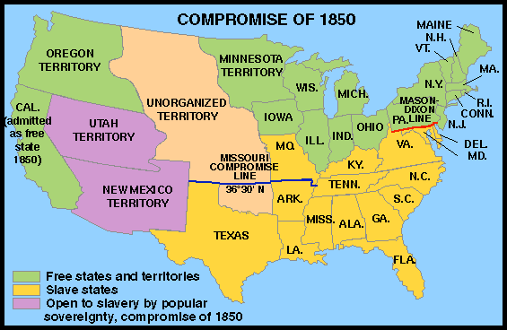

Source: Tindall's A Narrative History Gallery http://www.wwnorton.com/college/history/ushist/timeline/comp1850.htm

- How were future new states to decide if they entered the Union as a free or slave state?
- What was the Fugitive Slave Law?
- How many slave states are there in 1850?
- How many free states are there in 1850?
- What evidence is there on the map to show a past compromise?

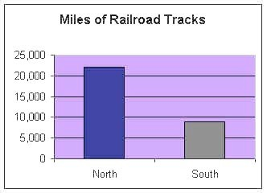
DOCUMENT 2
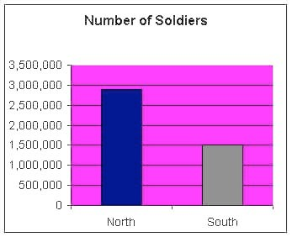
Civil War Graphs

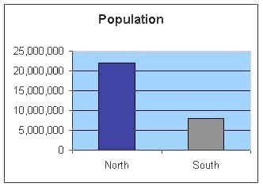

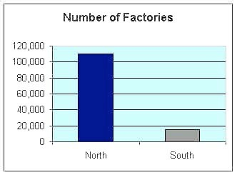

- Using the Population graph, which section of the country had almost twice the number of people living there? North or South?
- Using the Number of Soldiers graph, which section of the country had almost twice the number of soldiers in their army? North or South?
- Using the Number of Factories graph, what is the difference between the economies of the North and South?
- Using the Miles of Railroad Tracks graph, which section had a better railroad system to transport goods and supplies? North or South?
- Using all the graphs, list 3 reasons and explain why the North would do better in a war against the South.
- Explain why the information on this page is accurate or not accurate. Where could you look to verify the data?

DOCUMENT 3
Sectional Differences

HISTORICAL BACKGROUND:

The sectional division between North and South began in colonial times and resulted from geographical differences. In the South, the earliest settlers found the warm climate and fertile soil ideal for growing tobacco. They started many tobacco plantations and brought in black slaves from Africa to provide most of the labor. In time, other plantation crops, especially cotton, sugar cane, and sugar beets, were found to thrive in the South. The South thus quickly established a rural way of life supported by an agricultural economy based on slave labor.

The cooler climate and rocky soil in the North were not suitable for establishing plantations or large farms. As a result of those and other factors, the North's economy came to depend more on trade than on agriculture. Industry and commerce were centered in the North. Many factories using mass-production methods had sprung up there, and cities grew rapidly." The North developed an intricate railway system and shipping industry to transport the manufactured goods.
Source: A-Z History http://school.discovery.com/homeworkhelp/worldbook/atozhistory/c/HEAD1

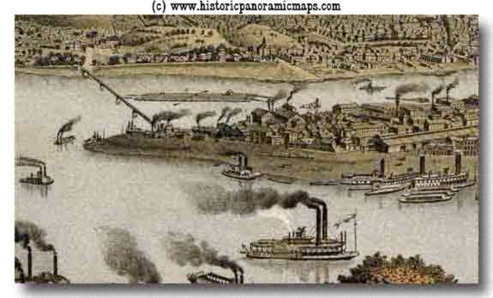
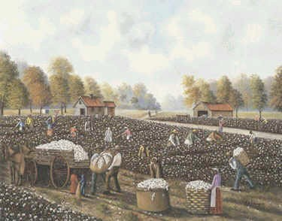

- Describe the economy of the South. How did the people make a living? What did they need for this type of economy?
- Describe the economy of the North. How did the people in North make a living? What did they need for this type of economy?
- What is the difference between the Northern and Southern economies?

DOCUMENT 4

Slavery

HISTORICAL BACKGROUND:

Harriet Beecher Stowe published the best-selling antislavery novel, Uncle Tom's Cabin, in 1852. She wrote this book to show that slavery was evil and that the Fugitive Slave Law was unjust. Many Northerners viewed slavery as wrong. Abolitionists wanted to end slavery and some helped slaves escape to the North and Canada. The Southerner's believed that they were stealing their property.

Mrs. Webb's reading of Uncle Tom's Cabin was reviewed in Boston's The Liberator on December 15, 1855.

"Mrs. Webb read to an audience of 1300 persons. We trust that the story of 'Uncle Tom' may find access to thousands of hearts, and so hasten the day when the millions of whom he is the representative shall shake off the fetters (chains) of cruel bondage, and stand erect in the dignity of that freedom ."

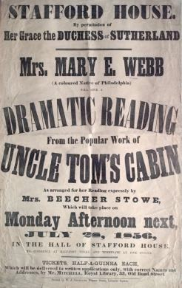

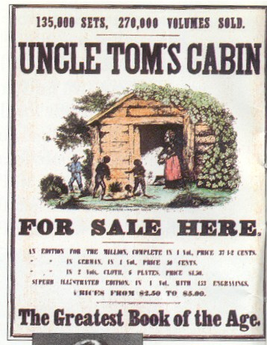

Uncle Tom's Cabin By Harriet Beecher Stowe Published in 1852

In March 1862, Harriet Beecher Stowe visited the White House and upon meeting President Abraham Lincoln, said, "So this is the little lady who made this big war?"

- What did Harriet Beecher Stowe write about in Uncle Tom's Cabin?
- Did many people read Uncle Tom's Cabin? Explain your answer.
- What effect did Uncle Tom's Cabin have in the North? How did it make people feel about slavery?

DOCUMENT 5
Lincoln Elected President

HISTORICAL BACKGROUND:

November 6, 1860 - Abraham Lincoln, who had declared "Government cannot endure permanently half slave, half free..." is elected president.

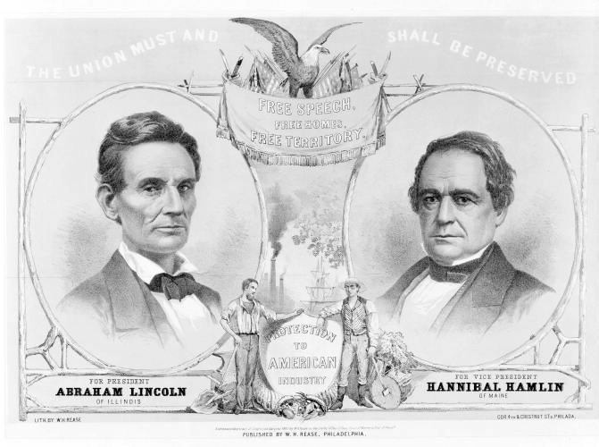
Dec 20, 1860 - South Carolina secedes from the Union. Followed within two months by Mississippi, Florida, Alabama, Georgia, Louisiana and Texas. Seven states of the Deep South, those in which the slavery system is most entrenched, leave the Union. Many Southerners favored secession as part of the idea that the states have rights and powers which the federal government cannot legally deny. The supporters of states' rights held that the national government was a league of independent states, any of which had the right to secede.
Source: American Political Prints, 1766 - 1876: A Catalog of the Collections in the Library of Congress, 1991, by Bernard F. Reilly, Jr.

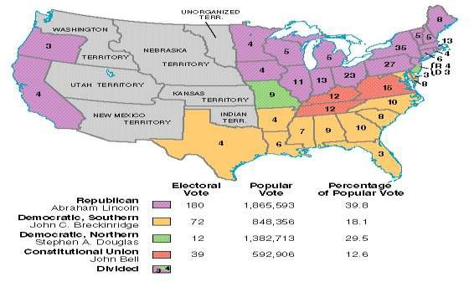

- Using Lincoln's 1860 campaign poster, what did the Republican party support?
- What does the phrase "Free Territory" mean?
- What part of the country would vote for Lincoln? Why?
- Why would the election of Lincoln cause Southern states to leave the Union?
- What did the South mean by the phrase "state's rights"?

Additional Documents

DOCUMENT 6

Excerpt from a speech by Albert Gallatin Brown, a Mississippi politician September 26, 1860

(The Northerners) hate us now, and they teach their children in their schools and churches to hate our children...the John Brown raid...the abolitionists among us, tell the tale...The North is accumulating power, and it means to use that power to emancipate (free) your slaves...Disunion is a fearful thing, but emancipation is worse. Better leave the union in the open face of day, than be lighted from it at midnight by the arsonist's torch."

DOCUMENT 7

Excerpt from Dred Scott v. Sanford, Supreme Court decision, 1857

...upon full and carefull consideration of the subject, the court is of the opinion, that, upon the facts stated...Dred Scott was not a citizen of Missouri within the meaning of the constitution of the United States and note entitled as such to sue in its courts.

DOCUMENT 8

Declarations of Causes of Seceding States South Carolina Declaration of the Immediate Causes Which Induce and Justify the Secession of South Carolina from the Federal Union
Excerpts written by C. G. Memminger

In pursuance of this Declaration of Independence, each of the thirteen States proceeded to exercise its separate sovereignty; adopted for itself a Constitution, and appointed officers for the administration of government in all its departments-- Legislative, Executive and Judicial. For purposes of defense, they united their arms and their counsels; and, in 1778, they entered into a League known as the Articles of Confederation, whereby they agreed to entrust the administration of their external relations to a common agent, known as the Congress of the United States, expressly declaring, in the first Article "that each State retains its sovereignty, freedom and independence, and every power, jurisdiction and right which is not, by this Confederation, expressly delegated to the United States in Congress assembled."

We, therefore, the People of South Carolina, by our delegates in Convention assembled, appealing to the Supreme Judge of the world for the rectitude of our intentions, have solemnly declared that the Union heretofore existing between this State and the other States of North America, is dissolved, and that the State of South Carolina has resumed her position among the nations of the world, as a separate and independent State; with full power to levy war, conclude peace, contract alliances, establish commerce, and to do all other acts and things which independent States may of right do.
Adopted December 24, 1860

Sources: Library of Congress
J.A. May & J.R. Faunt, South Carolina Secedes (U. of S. Car. Pr, 1960), pp. 76-81

DOCUMENT 9

Jefferson Davis, Message to the Confederate Congress (April 29, 1861)

―It was by the delegates chosen by the several States… that the Constitution of the United States was framed in 1787 and submitted to the several States for ratification… [These] States endeavored in every possible form to exclude the idea that the separate and independent sovereignty of each State was merged into one common government and nation, and… to impress on the Constitution its true character – that of a compact between independent States.

… Amendments were added to the Constitution placing beyond any pretense of doubt the reservation by the States of all their sovereign rights and powers not expressly delegated to the United States by the Constitution.

Strange, indeed, … [the Constitution has] proved unavailing to prevent the rise and growth in the Northern States of a political school which has persistently claimed that the government thus formed was not a compact between States, but was in effect national government, set up above and over the States.

DOCUMENT 10

John Brown’s Last Speech

November 2, 1859
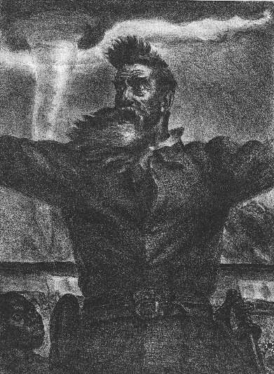
(American State Trials, ed. by J. D. Lawson, Vol. VI, p. 800 ff.)

John Brown, most fanatical of abolitionists, planned to incite a general insurrection of slaves in Virginia and form a free state somewhere in the mountains of western Maryland and Virginia. With the aid of funds gathered in New England and New York he collected supplies and arms at a farmhouse near Harper's Ferry, Virginia, and on the night of October 16 moved on the town of Harper's Ferry and captured the government armory. United States marines under the command of Col. R. E. Lee carried the armory by assault, and captured Brown and some of his followers. He was indicted for treason and for conspiring with slaves to commit murder, convicted, and sentenced to be hanged. On Brown, see 0.
G. Villard, John Brown; F. B. Sanborn, Life end Letters of John Brown; R. P. Warren, John Brown. The trial is given in full in American State Trials, Vol. VI.

I have, may it please the Court, a few words to say.

In the first place, I deny everything but what I have all along admitted,—the design on my part to free the slaves. I intended certainly to have made a clean thing of that matter, as I did last winter, when I went into Missouri and there took slaves without the snapping of a gun on either side, moved them through the country, and finally left them in Canada. I designed to have done the same thing again, on a larger scale. That was all I intended. I never did intend murder, or treason, or the destruction of property, or to excite or incite slaves to rebellion, or to make insurrection.

DOCUMENT 11

“Cotton is King,” a speech given by James Henry Hammond on March 4, 1858.

…It appears, by going to the report of the Secretary of Treasury, which are authentic, that last year the United States exported in round numbers $279,000,000 worth of domestic produce, excluding gold and foreign merchandise re-exported. Of this amount $158,000,000 worth is the clear produce of the South; articles that are not and cannot be made at the North. There are then
$80,000,000 worth of exports of products of the forest, provisions and breadstuffs. If we assume that the South made but one third of these, and I think that is a low calculation, our exports were
$185,000,000, leaving to the North less than $95,000,000.

In addition to this, we sent to the North $30,000,000 worth of cotton, which is not counted in the exports. We sent to her $7 of $8,000,000 worth of tobacco, which is not counted in the exports. We sent naval stores, lumber, rice, and many other minor articles. There is no doubt that we sent to the North $40,000,000 in addition; but suppose the amount to be $35,000,000, it will give us a surplus production of $220,000,000. But the recorded exports of the South now are greater than the whole exports of the United States in any year before 1856. They are greater than the whole average exports of the United States for the last twelve years, including the two extraordinary years of 1856 and 1857….

With an export of $220,000,000 under the present tariff, the South organized separately would have $40,000,000 of revenue. With one-fourth the present tariff, she would have a revenue with the present tariff adequate to all her wants, for the South would never go to war; she would never need an army or a navy, beyond a few garrisons on the frontiers and a few revenue cutters….

No, you dare not make war on cotton. No power on earth dares to make war upon it.
Cotton is king….
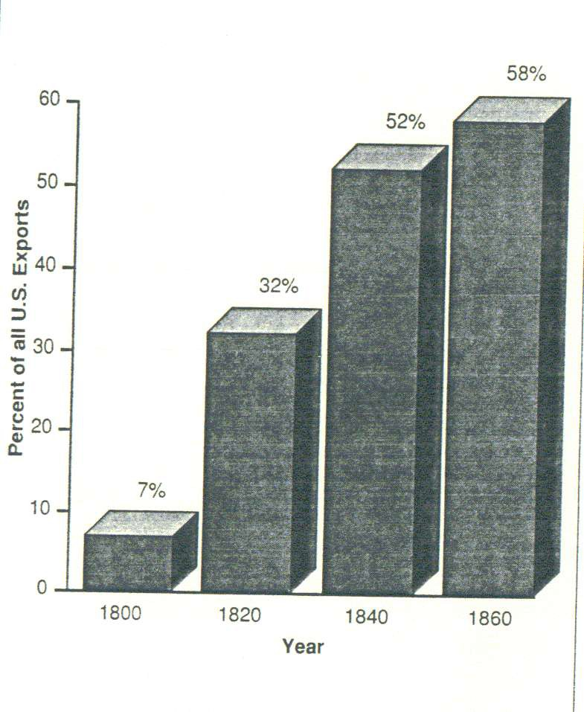

DOCUMENT 12

Cotton Exports as Percentage

of All U.S. Exports, 1800-1860.

DOCUMENT 13

Compromise of 1850

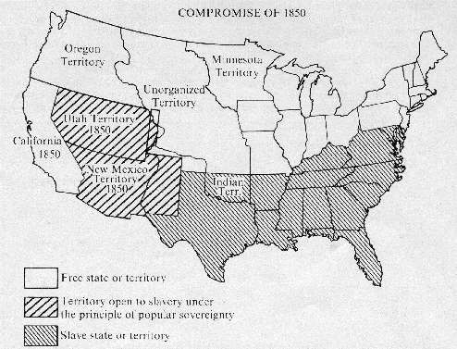

Dates of Secession and Percentages of Slaveholders

Dec. 20, 1860 |  |  |  |  |  |  |  |  |  |  |  |  | 8.7
Dec. 20, 1860 |  |  |  |  |  |  |  |  |  |  |  | 4 | 8.7
Jan. 9, 1861
Jan. 9, 1861 |  |  |  |  |  |  |  |  |  |  | 48 |  | 8.7
Jan. 10, 1861
Jan. 10, 1861 |  |  |  |  |  |  |  | 36 |  |  |  |  | 8.7
Jan. 11, 1961
Jan. 11, 1961 |  |  |  |  |  |  | 35.1 |  |  |  |  |  | 8.7
Jan. 19, 1861
Jan. 19, 1861 |  |  |  |  |  |  |  |  | 38 |  |  |  | 8.7
Jan. 26, 1861
Jan. 26, 1861 |  |  |  |  |  | 32.2 |  |  |  |  |  |  | 8.7
Jan. 26, 1861 |  |  |  |  | 8.5 |  |  |  |  |  |  |  | 8.7
Feb. 1, 1861
Feb. 1, 1861 |  |  |  | 2 |  |  |  |  |  |  |  |  | 8.7

0 10 20 30 40 50 60
States and Dates of Secession
South TexasLousiana Georgia AlabamaFlorida MississippiCarolina
Percentages of Slaveholders

DOCUMENT 14



