Name:_________________________________ Date: _________________________
APUSH 11-C Prof. Ruthie García Vera PJMJCH Marista High School

DBQ Essay Early Presidential Policies

Part I. Document Analysis
Read and answer the questions for the following 24 documents. Use outside information to do so if necessary. Print and bring to class. Support your response with relevant facts, examples and details. Include additional outside information and include references in your work.

Historical Context: The early presidents of the United States (1789-1837) are recognized for their foreign and domestic policies that helped the country become a strong nation. Through their leadership, these founding fathers led the states through its beginning by establishing the first republican form of government that has become one of the strongest in the world today.

Prompt:
To what extent did the early presidents build a strong nation through their leadership on domestic and foreign policies?

Document 1
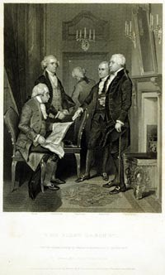
1. According to the painting, what precedent from George Washington’s presidency do the men in the painting represent?

2. Is the document about foreign or domestic policy?

Document 2

“….the duty and interest of the United States require, that they should with sincerity and good faith adopt and pursue a conduct friendly and impartial toward the belligerent Powers (nations at war); … citizens of the United States shall render himself liable to punishment or forfeiture (surrender) under the law of nations, by committing, aiding, or abetting hostilities against any of the said Powers…” The Proclamation of Neutrality, April 22, 1793… George Washington, 1793

3. What was the purpose of the Proclamation of Neutrality? Is it about foreign or domestic policy?

Document 3

“I have already intimated to you the danger of parties in the State…” “ It is our true policy to steer clear of permanent alliances with any portion of the foreign world.” Washington’s Farewell Address, 1796

4. What warnings did George Washington give to the people of the United States in his Farewell Address? Is the document about foreign or domestic policy?

Document 4

“…And whereas, it is in my judgment necessary under the circumstances of the case to take measures for calling forth the militia…the most solemn conviction that the essential interests of the Union demand it…therefore I do command all persons being insurgents …to disperse and retire peacefully to their respective abodes…” Whiskey Rebellion Proclamation George Washington, 1794

5. According to the document, what is the purpose of the Proclamation? Is it about foreign or domestic policy?

Document 5

“That if any persons shall unlawfully combine or conspire together, with intent to oppose any measure or measures of the government of the United States… they shall be deemed guilty of a high misdemeanor, and on conviction, before any court of the United States having jurisdiction thereof, shall be punished by a fine not exceeding five thousand dollars, and by imprisonment during a term not less than six…”John Adams, Sedition Act, 1798

“Be it enacted . . ., That whenever there shall be a declared war between the United States and any foreign nation or government …the President of the United States shall make public proclamation of the event, all natives, citizens…or subjects of the hostile nation or government… who shall be within the United States… shall be liable to be apprehended, restrained, secured and removed…” John Adams, Alien Act, 1798

6. What is the main idea of the Sedition Act?

7. What is the main idea of the Alien Act?

8. Are the documents about foreign or domestic policy? Why?

Document 6

“RESOLVED, That the General Assembly of Virginia… doth particularly protest against…the two late cases of the "Alien and Sedition Acts" passed at the last session of Congress; the first of which exercises a power no where delegated to the federal government…” John Adams, Virginia Resolution, 1798

“THE representatives of the good people of this commonwealth in general assembly convened, having maturely considered the answers of sundry (various) states …respecting certain unconstitutional laws of Congress, commonly called the alien and sedition laws … expose the unconstitutionality of those obnoxious laws…” John Adams, Kentucky Resolution 1799

9. Using the documents above, what is the main point both resolutions are making about obeying the federal law of the Alien and Sedition Act? Are these documents foreign or domestic policy?

Document 7

“Although it is very true that we ought not to involve ourselves in the political system of Europe, but to keep ourselves always distinct and separate from it if we can, we are endeavoring (trying) to adjust all our differences with France by amicable negotiation…render it my indispensable (inevitable) duty to recommend to your consideration effectual measures of defense…..I shall institute a fresh attempt at negotiation, and shall not fail to promote and accelerate an accommodation on terms compatible with the rights, duties, interests, and honor of the nation.” Speech by John Adams in a Special Message to Congress on the XYZ Affair" (May 16, 1797)

10. What was the XYZ Affair? What is John Adams position on negotiations with France after the XYZ Affair?
Is the document about foreign or domestic policy?

Document 8

Paris, July 11, 1786

Dear Sir:

I ask a fleet of 150 guns, the one half of which shall be in constant cruise. This fleet built … will cost 450,000 pounds sterling. It’s annual expence is 300 pounds sterling a gun, including every thing: this will be 45,000 pounds sterling a year. … Were we to charge all this to the Algerine war it would amount to little more than we must pay if we buy peace. But as it is proper and necessary that we should establish a small marine force (even were we to buy a peace from the Algerines,) and as that force laid up in our dockyards would cost us half as much annually as if kept in order for service, we have a right to say that only 22,500 pounds sterling per annum should be charged to the Algerine war. (Cappon 1959, 142-143) Excerpt, Letter Thomas Jefferson to John Adams.

11. Who were the Barbary Pirates? What does Jefferson conclude about whether or not to continue paying tribute to the Algerines?

12. How does his view change when he becomes President? Why do you think he does this?

Document 9

Before you receive this, you will have heard, through the channel of the public papers, of the cession of Louisiana by France to the United States…That the treaty may be ratified in time, I have found it necessary to convene Congress on the 17th of October… Letter from President Thomas Jefferson to William Dunbar, July 17, 1803

“The First Consul of the French Republic desiring to give to the United States … doth hereby cede to the United States in the name of the French Republic forever and in full Sovereignty the said territory with all its rights and appurtenances as fully and in the Same manner as they have been acquired by the French Republic in virtue of the above mentioned Treaty …” Thomas Jefferson, Article II, Treaty between the United States of America and the French Republic, 1803

13. In the letter, Thomas Jefferson states “the treaty may be ratified [between France and USA] in time”. If the agreement signed is called a treaty, does that give President Jefferson the constitutional right to make the purchase? Explain your answer.

14. According to the articles above, how did Jefferson obtain the land owned by France (Louisiana Territory) as a territory for the United States? Are the documents about foreign or domestic policy?

Document 10

15. Using the map below, why is the possession of the Louisiana Territory in 1803 important to the United States? Is the map about foreign or domestic policy?

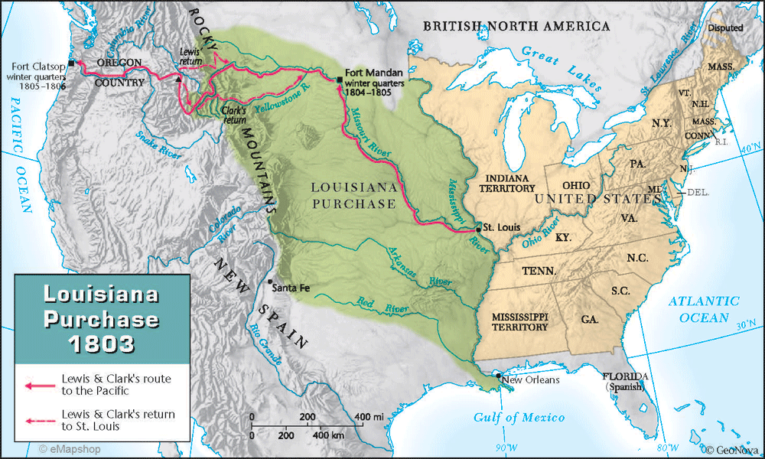

Document 11

“Be it enacted . . ., That an embargo be, and hereby is laid on all ships and vessels in the ports and places within the limits or jurisdiction of the United States... and that no clearance be furnished to any ship or vessel bound to such foreign port or place…

Section 2. And be it further enacted, That during the continuance of this act, no registered, or sea letter vessel, having on board goods, wares and merchandise, shall be allowed to depart from one port of the United States…” Thomas Jefferson, Embargo Act, 1807

The United States was very angry with Britain and France for interfering with trade. In 1807, President Jefferson convinced Congress to pass the Embargo Act. This law stated that Americans could not trade with other countries. Jefferson thought the embargo would hurt France and Britain by cutting off their supplies. However, it also hurt Americans. (See graph). The law was replaced by the Non intercourse Act. It allowed Americans to trade with all nations except France and Britain.

16. What is the main purpose of the Embargo Act? What was its effect in the United States?

Document 12

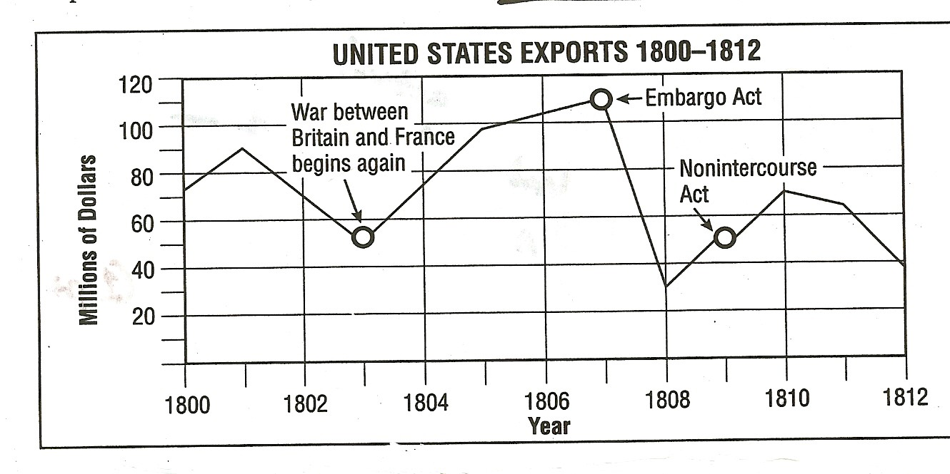

17. How much money did the United States lose in exports in the first year after the Embargo Act was passed? Is it about foreign or domestic policy?

Document 13

To the Senate and House of Representatives of the United States:

“British cruisers (ships) have been in the practice of violating the rights and the peace of our coasts…Our commerce has been plundered (taken) in every sea, the great staples of our country have been cut off from our legitimate markets and a destructive blow aimed at our agricultural and maritime interest and now we behold…on the side of Great Britain a state of war against the United States.”

“I communicate to Congress certain documents, being a continuation of those heretofore laid before them on the subject of our affairs with Great Britain. British cruisers have been in the continued practice of violating the American flag on the great highway of nations, and of seizing and carrying off persons sailing. ..Thousands of American citizens, under the safeguard of public law and of their national flag, have been torn from their country and from everything dear to them; have been dragged on board ships … of a foreign nation and exposed, under the severities of their discipline.” James Madison Special Message to Congress on the Foreign Policy Crisis War Message (June 1, 1812)

18. What is James Madison’s main point in his address to Congress? Is it about foreign or domestic policy? List two complaints the President is making in this quote?

Document 14

“Among the means of advancing the public interest the occasion is a proper one for recalling the attention of Congress to the great importance of establishing throughout our country the roads and canals which can best be executed under the national authority. “ State of the Union Address, James Madison, December 5, 1815

19. What is James Madison’s belief about the internal improvements (public transportation)?

Document 15

“I shall behold it blessed with tranquility (peace) and prosperity at home and with peace and respect abroad. I can indulge the proud reflection that the American people have reached in safety and success their 40th year as an independent nation...” James Madison’s, State of the Union, December 3, 1816

20. What does James Madison state as his main accomplishment at the end of his presidency? Is it about foreign or domestic policy?

Document 16

“That the American continents, by the free and independent condition.., are henceforth not to be considered as subjects for future colonization by any European powers....Our policy, in regard to Europe…, nevertheless remains the same, which is, not to interfere in the internal concerns of any of its powers; It is impossible that the allied powers (Europe) should extend their political system to any portion of either continent, without endangering our peace and happiness…” James Monroe

21. What is the main idea from the document above? Is it about foreign or domestic policy?

22. How is James Monroe’s foreign policy like George Washington’s foreign policy?

Document 17
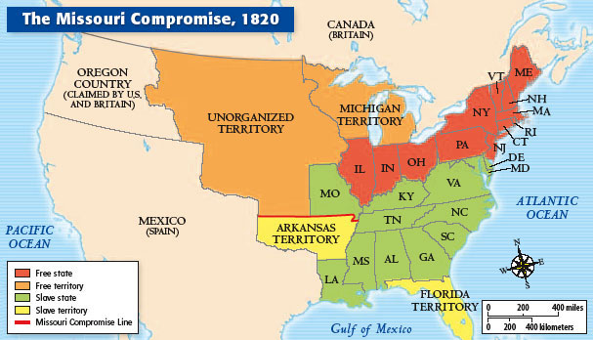

Map of the United States showing the free and slave states and territories following the Missouri Compromise of 1820.

23. How was balance maintained between free and slave states with the Missouri Compromise of 1820?
Is the map about foreign or domestic policy?

Document 18

“His Majesty cedes to the United States, in full property and sovereignty, all the territories which belong to him, situated to the eastward of the Mississippi, known by the name of East and West Florida. ...The said archives and documents shall be left in possession of the commissaries(representative) or officers of the United States, duly authorized to receive them.” Adams Onis Treaty, Article II

“The inhabitants of the ceded territories shall be secured … without any restriction; and all those who may desire to remove to the Spanish dominions shall be permitted to sell or export their effects, at any time whatever, without being subject, in either case, to duties.” Adams Onis Treaty, Article V

24. According to Article II, what territory was ceded to the United States in the Adams Onis Treaty?

25. According to Article V, how were the people of the ceded territory to be treated?

26. Are the articles about foreign or domestic policy?

Document 19

“ So partial are the effects of the [tariff] system, that its burdens are exclusively on one side and its benefits on the other. It imposes on the agricultural interest of the South, including the Southwest, and that portion of the country particularly engaged in commerce and navigation, the burden not only of sustaining the system itself, but that also of the Government. In stating the case thus strongly, it is not the intention of the committee to exaggerate. If exaggeration were not unworthy of the gravity of the subject, the reality is such as to make it unnecessary...” South Carolina's Protest Against Andrew Jackson’s Tariff of 1828. By John C. Calhoun (Anonymously).

27. What was the Tariff of 1828? Why did South Carolina threaten secession it? Is the tariff about foreign or domestic policy?

Document 20

Sir, I deprecate and deplore this tone of thought and feeling. I deem far otherwise of the union of the states, and so did the framers of the constitution themselves. What they said I believe; fully and sincerely believe, that the union of the states is essential to the prosperity and safety of the states. I am a unionist, and in this sense, a national republican. I would strengthen the ties that hold us together. Far, indeed, in my wishes, very far distant be the day, when our associated and fraternal stripes shall be severed asunder, and when that happy constellation under which we have risen to so much renown, shall be broken up and be seen sinking star after star, into obscurity and night!....

Should our Union fall into pieces, which these doctrines may cause to happen, I fear to see "States dissevered, discordant, belligerent; ... a land rent with civil feuds, or drenched, ... in fraternal blood!" Let us not have "Liberty first and Union afterwards", but "Liberty and Union, now and forever, one and inseparable! Webster-Hayne Debate (Against Andrew Jackson’s policy) , January 26, 1830
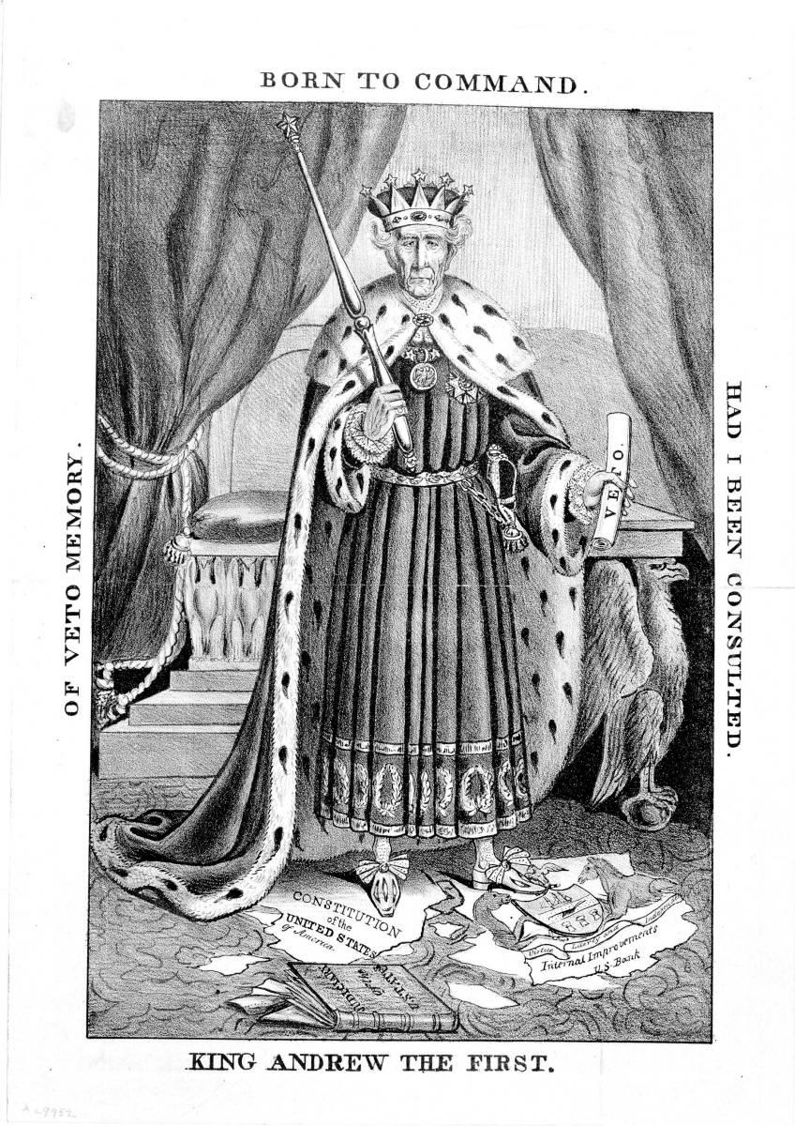
The Hayne-Webster Debate was an unplanned series of speeches in the Senate, during which Robert Hayne of South Carolina interpreted the Constitution as little more than a treaty between sovereign states, and Daniel Webster expressed the concept of the United States as one nation.

28. Who’s opinion is represented in the document?

29. The coalition that supported Andrew Jackson for president had a large faction of advocates of state sovereignty? What does this mean?

Document 21

Analyze the following cartoon.

30. What Presidential power does the cartoon show Jackson having? Why do you believe the artist chose to depict him in this way?

31. What controversial action did President Jackson take in 1832 that is the subject of this cartoon? What items in the cartoon support this notion?

32. Do you feel the artist supports President Jackson’s action? Why or why not?

Document 22

“It is to be regretted that the rich and powerful too often bend the acts of government to their selfish purposes….Distinctions in society will always exist under every just government….But when the laws undertake to…. Make the rich richer and the potent more powerful, the humble members of society….have a right to complain of the injustice of their Government.”

The bill “to modify and continue” the act entitled “An act to incorporate the subscribers to the Bank of the United States” was presented to me on the 4th July instant. Having considered it with that solemn regard to the principles of the Constitution which the day was calculated to inspire, and come to the conclusion that it ought not to become a law, I herewith return it to the Senate, in which it originated, with my objections.

A bank of the United States is in many respects convenient for the Government and useful to the people. Entertaining this opinion, and deeply impressed with the belief that some of the powers and privileges possessed by the existing bank are unauthorized by the Constitution, subversive of the rights of the States, and dangerous to the liberties of the people, I felt it my duty at an early period of my Administration to call the attention of Congress to the practicability of organizing an institution combining all its advantages and obviating these objections. I sincerely regret that in the act before me I can perceive none of those modifications of the bank charter which are necessary, in my opinion, to make it compatible with justice, with sound policy, or with the Constitution of our country. Andrew Jackson's Bank Veto, 1832.

33. Who did Jackson think he was defending when he vetoed the National Bank? According to Jackson, which members of society benefited from the National Bank? Is this veto about foreign or domestic policy?

Document 23

For what would you exchange your share in the advantages and honor of the Union? For the dream of a separate independence, a dream interrupted by bloody conflicts with your neighbors and a vile dependence on a foreign power. If your leaders could succeed in establishing a separation, what would be your situation? Are you united at home? Are you free from the apprehension of civil discord, with all its fearful consequences? . . . . . But the dictates of a high duty oblige me solemnly to announce that you cannot succeed. The laws of the United States must be executed. I have no discretionary power on the subject; my duty is emphatically pronounced in the Constitution. Those who told you that you might peaceably prevent their execution deceived you; they could not have been deceived themselves. They know that a forcible opposition could alone prevent the execution of the laws, and they know that such opposition must be repelled. Their object is disunion.

But be not deceived by names. Disunion by armed force is treason. Are you really ready to incur its guilt?..... The consequence must be fearful for you, distressing to your fellow citizens here and to the friends of good government throughout the world.

Andrew Jackson issued the above proclamation appealing to the Carolinians to forsake the treacherous paths of nullification and disunion. 1832.

34. What was Jackson’s opinion of southern secession? Is this proclamation about foreign or domestic policy?

Document 24

As a means of effecting this end, I suggest for your consideration the propriety of setting apart an ample district west of the Mississippi, and without [outside] the limits of any state or territory now formed, to be guaranteed to the Indian tribes as long as they shall occupy it, each tribe having a distinct control over the portion designated for its use. There they may be secured in the enjoyment of governments of their own choice, subject to no other control from the United States than such as may be necessary to preserve peace on the frontier and between the several tribes. . . . .This emigration should be voluntary, for it would be as cruel as unjust to compel the aborigines to abandon the graves of their fathers and seek a home in a distant land.... President Andrew Jackson's endorsement of Indian removal, 1829.

“All preceding experiments for the improvement of the Indians have failed. It seems now to be an established fact that they cannot live in contact with a civilized community and prosper….No one can doubt the moral duty of the Government …. To protect and if possible to preserve and perpetuate the scattered remnants of this race….” Jackson’s message to Congress concerning the removal of Native Americans from east of the Appalachian Mountains, December 7, 1835

35. Who is the ‘civilized community’ according to Jackson? Why did Jackson feel that relocating the Native Americans was the best policy? Are his actions about foreign or domestic policy?

Part II: Using information from the documents and your knowledge of United States history, write a well-organized four paragraph document based essay that addresses the prompt and includes an introduction, the four paragraphs, and a conclusion. Use evidence from at least nine documents in your essay and references from outside information.

To what extent did the early presidents build a strong nation through their leadership on domestic and foreign policies?

1. Compare and contrast in a chart the following presidents as preparation to write your essay.
George Washington, John Adams, Thomas Jefferson, James Madison, James Monroe, Andrew Jackson.

- Identify their foreign policies.
- For each of the policies you identify, explain why the president believed that policy would benefit the United States and how this policy impacted the nation.
- Explain how it kept America isolated and/or neutral from European nations. In what ways did their actions have unintended consequences?

The chart will be worked in class on Monday, January 12, 2015 after the discussion of the DBQ.

2. Write a thesis statement that restates the essay prompt. Then, list the main points and document references you’ll be using. Keep in mind that some of your historical evidence and elaboration will come from previous knowledge.

3. Write a rough draft including the following:

a. Introduction- thesis statement
b. Skip lines. (for corrections)
c. Indent for each of FOUR paragraphs.
d. Write in third person narrative.
e. Use correct spelling, capitalization, and punctuation.

4. Handle in your rough draft on Tuesday, January 13, 2015.

5. You will re-write your essay and send before midnight by the date indicated in your class Lo Calendar page and at mrsruthie.net site after the draft has been corrected and returned to you.

